**实验1**

1.[SQL Sever2008版本要求](https://docs.microsoft.com/zh-cn/previous-versions/sql/sql-server-2008/ms143506(v=sql.100)?redirectedfrom=MSDN" \l "%E6%9C%8D%E5%8A%A1%E5%99%A8%E7%89%88%E6%9C%AC64-%E4%BD%8D%E5%92%8C-32-%E4%BD%8D)

WIN7适用标准版，开发版，工作组版，学习版。

2.**“实例”**就是一个SQL Server数据库引擎。每个实例包含自己的数据库集、安全认证、配置设置、Windows服务和其他SQL Server对象。

**默认路径：**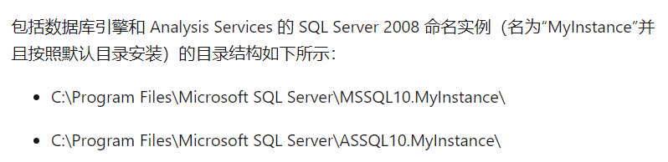

3.两种，Windows身份验证和SQL身份验证，身份验证处下拉更改

4.指为服务器配置服务账户和排序规则，可以相同

5.数据库引擎是指用于储存、处理和保护数据的核心服务。

分析服务，报表服务，集成服务

数据快速分析。

建立、管理和发布基于纸张或web的报表。

数据提取、转换、和加载。

**实验2**

2.1

4个

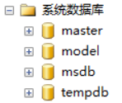

2.2.1

master、

2.2.2

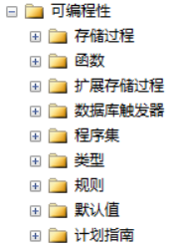

2.3.1

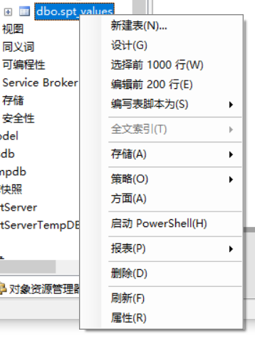

2.3.2

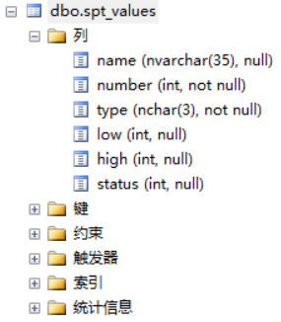

3.3

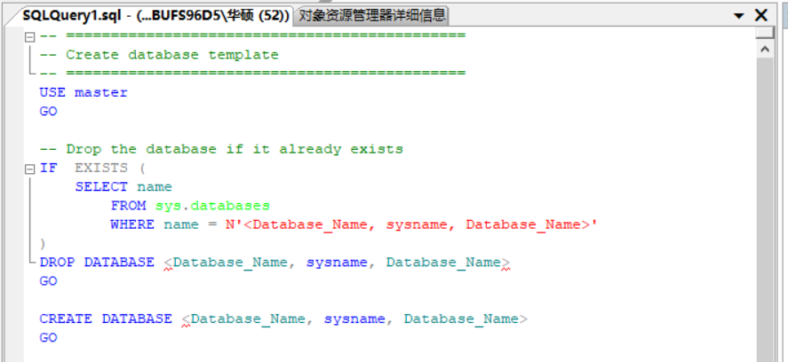

4.3

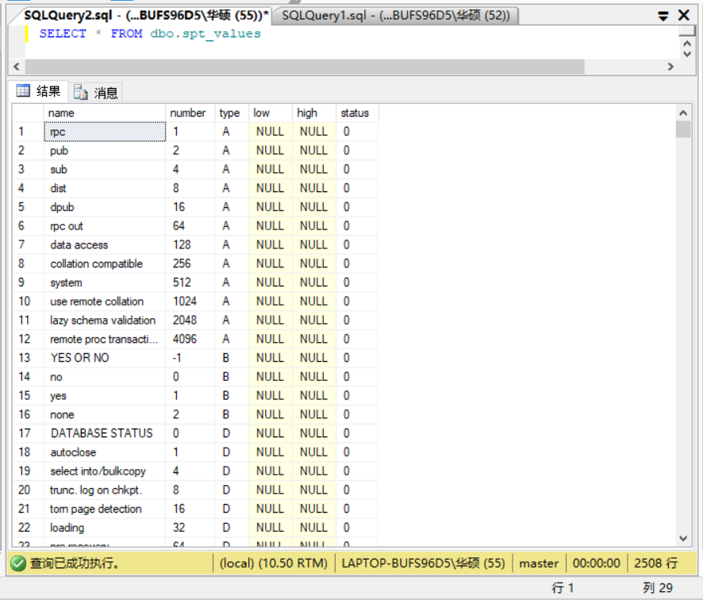

思考：

4

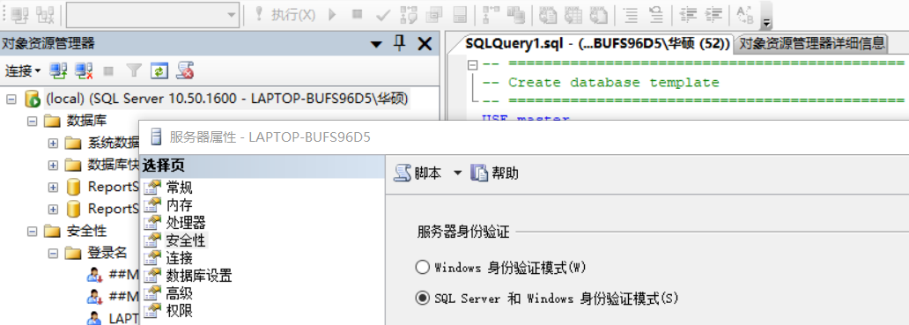

5.SQL Server事件探查，一个Sql的监视工具[使用指南](https://blog.csdn.net/firwind/article/details/79075629)

**实验3**

1.1

MYTEST

MYTEST.mdf

E:\Program Files\Microsoft SQL Server\MSSQL10_50.MSSQLSERVER\MSSQL\DATA

3MB

不限制增长

MYTEST_log

MYTEST_log.ldf

E:\Program Files\Microsoft SQL Server\MSSQL10_50.MSSQLSERVER\MSSQL\DATA

增量为 10％

1.2

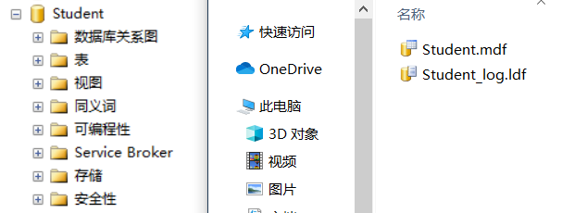



2.1

Products

prods_dat

增长的最大值限制为 10 MB

Products_log

2.2

3,5,2,5

2.3

2

Rsx1dat.mdf和Rsx2dat.ndf

5%

2.4

见文件

思考

1.右击->（属性->）重命名，可以

2.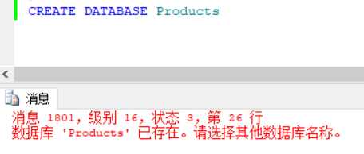

3.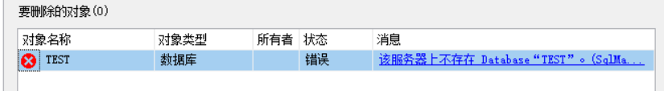

原因，反复删除

消息 3702，级别 16

无法删除数据库 “Sale_Management_Subsystem”，因为该数据库当前正在使用。

使用

USE MASTER

GO

DROP DATABASE Sale_Management_Subsystem

即可

4.能？

5.查询设计器更细致，对象资源管理器更便捷。

**实验4**

1关闭服务器避免占用，

2.附加需要管理员权限以及管理员对文件的完全控制

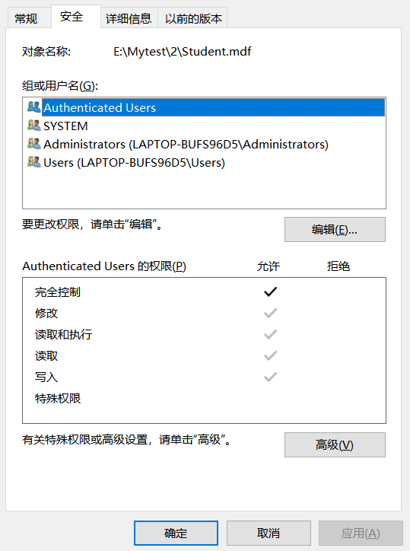

以管理员身份运行

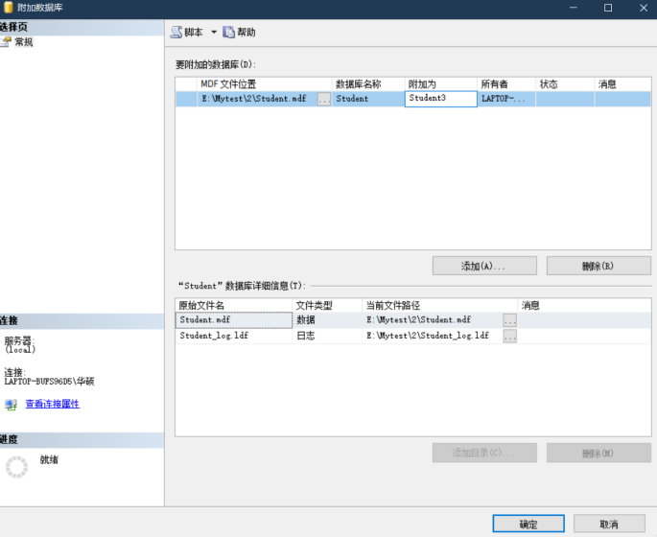

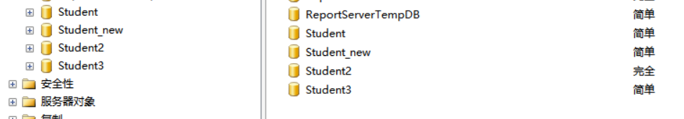

附加完成

3不在

4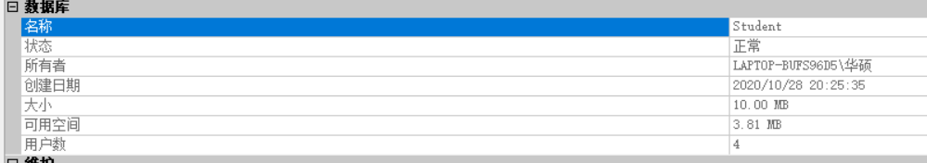

文件本身不大，看不出变化[收缩的解释](https://bbs.csdn.net/topics/70484031)

5将恢复类型改为简单，右击->任务->收缩文件

**思考**

1不能，只是不在项目中。

2文件给与管理员完全权限，管理员运行DBMS，即可进行附加操作

3右击选择复制数据库，按指导即可完成复制

**实验5**

****1.3****

**St_ID**

**St_ID,St_Name**

**datetime 系统默认（8位）**

**2**

****2.1****

**Std**

**S_NO**

**Smallint**

**年龄限制在15-20之间**

****2.2****

**St_ID,C_NO**

**Int**

**St_ID作为外键关联St_info的St_ID列**

****4****

**4.2**



****5****

**5.1**

**添加数据**

insert into St_Info values('2011150109','杨柳','女','1996-12-12','法学',NULL,NULL,NULL,NULL,NULL)

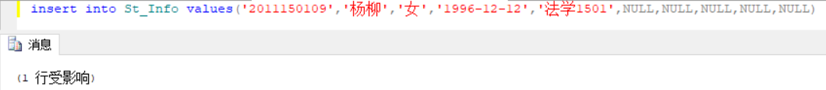

5.2

update St_Info set Cl_Name = '计算机科学' where St_ID='0603170109'

**修改数据**

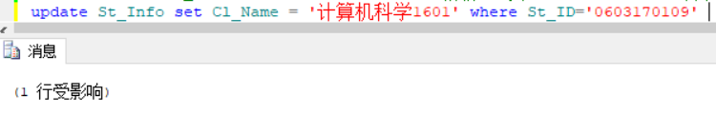



5.3

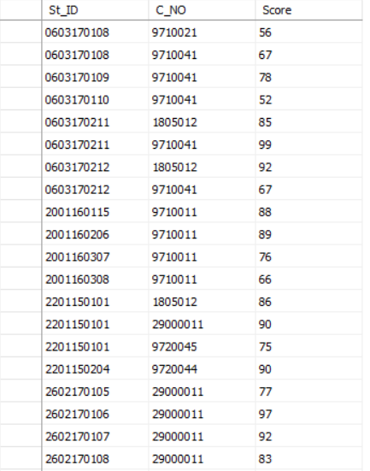

delete from S_C_Info where C_NO='9720013'

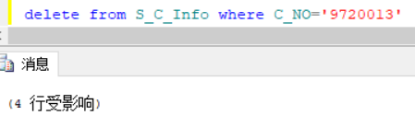

6

6.1

alter table s_c_Info add xklb char(4)

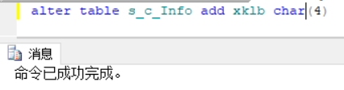

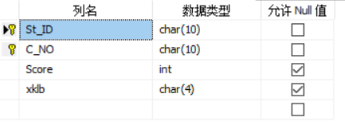

6.2

alter table C_Info

alter column C_credit tinyint

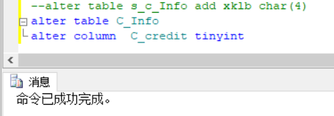

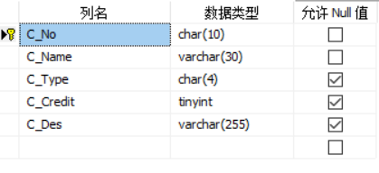

6.3

alter table S_C_Info

alter column xklb char(6)

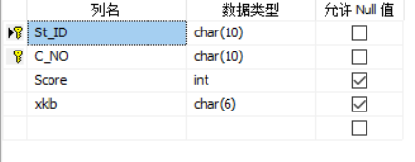

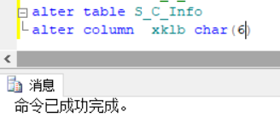

6.4

alter table S_C_Info

drop column xklb

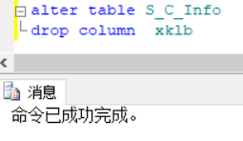

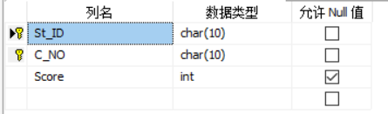

****思考****

****1能****

****2能****

****3不同****

****4****

****代码描述或者鼠标crtl选中多列****

****5****

****SQL Server创建和使用临时表:****  
创建临时表  
    方法一：  
        create table #临时表名(字段1 约束条件,  
                      字段2 约束条件,  
                  .....)  
        create table ##临时表名(字段1 约束条件,  
                          字段2 约束条件,  
                      .....)  
                        
    方法二：  
        select * into #临时表名 from 你的表;  
        select * into ##临时表名 from 你的表;  
注：以上的#代表局部临时表，##代表全局临时表  
删除临时表  
    drop table #临时表名;  
    drop table ##临时表名;

**实验6**

1.

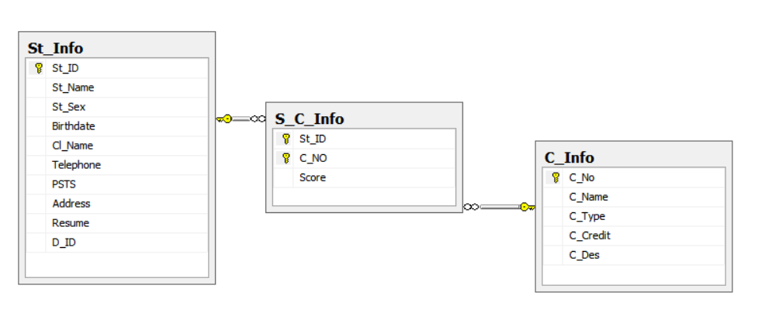

2.

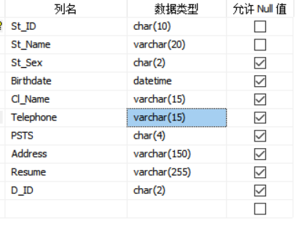

3.

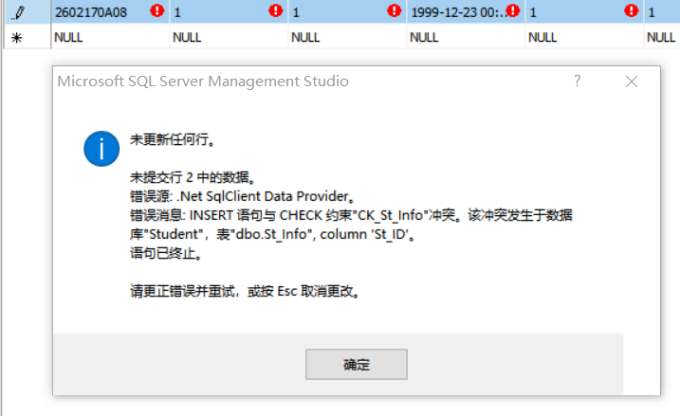

4.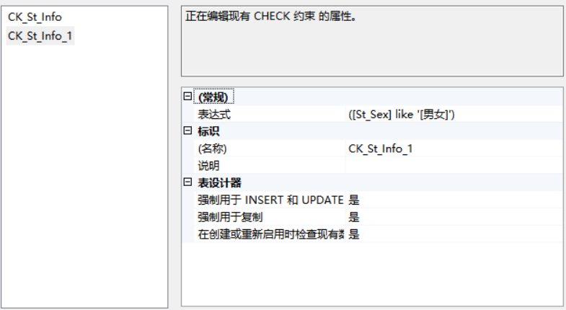

5.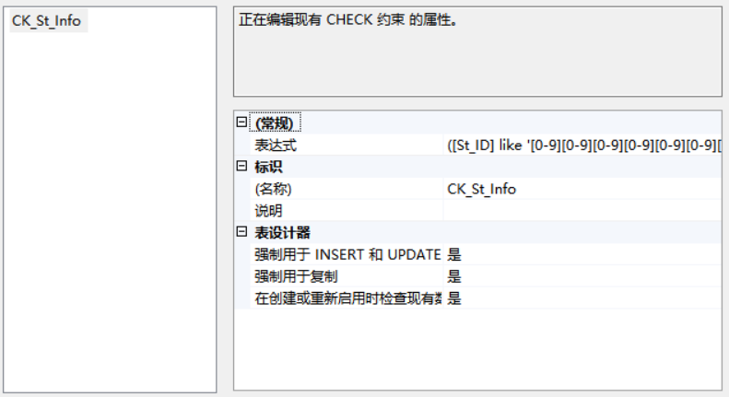

6.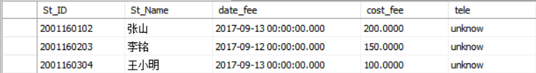

删除清除即可

7

St_ID

7.2

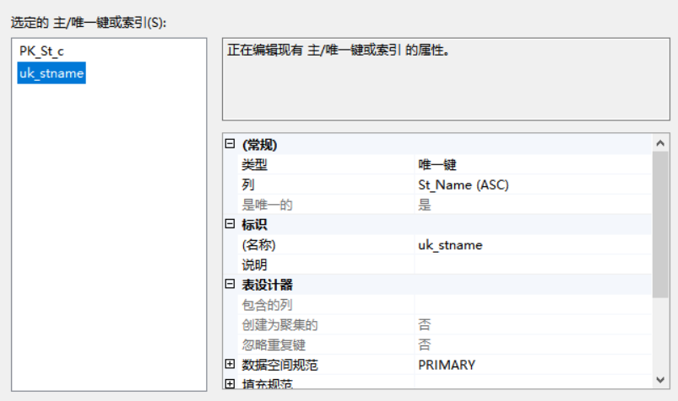

7.4

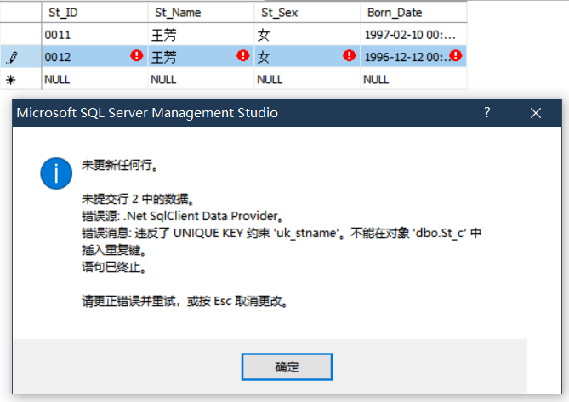

7.5

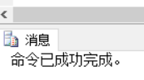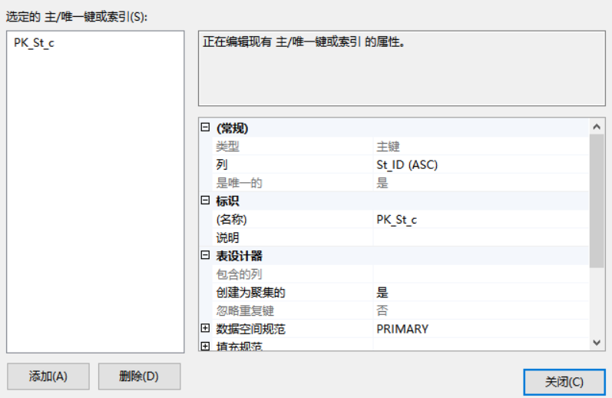

实验六

1.



2.



3.



4.

5.

6.

删除清除即可

7

St_ID

7.2



7.4



7.5



实验七

1.1

SELECT * FROM C_Info

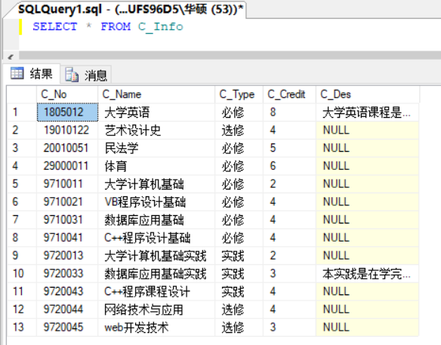

1.2

Year

SELECT TOP 10 St_name AS 姓名, Year(Birthdate) AS 出生年份, Cl_Name AS 班级 FROM St_Info

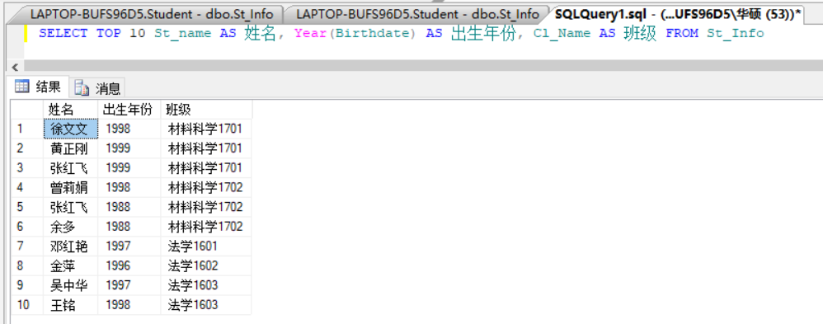

1.3

Year(Birthdate) = 1998

SELECT St_name AS 姓名, Year(GETDATE())-Year(Birthdate) AS 年龄 FROM St_Info WHERE Year(Birthdate) = 1998

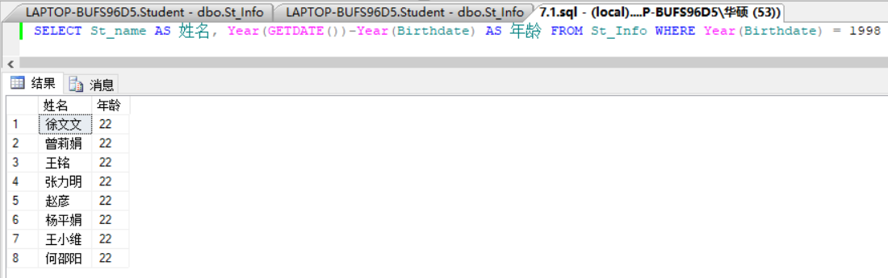

1.4

控制查询结果集无重复ID记录

前者去掉了重复的ID，后者显示了所有的符合条件的ID

SELECT DISTINCT St_ID FROM S_C_Info WHERE Score > 85

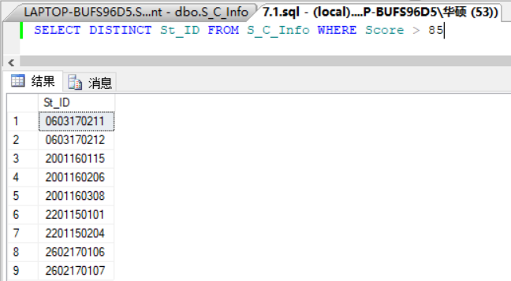

SELECT St_ID FROM S_C_Info WHERE Score > 85

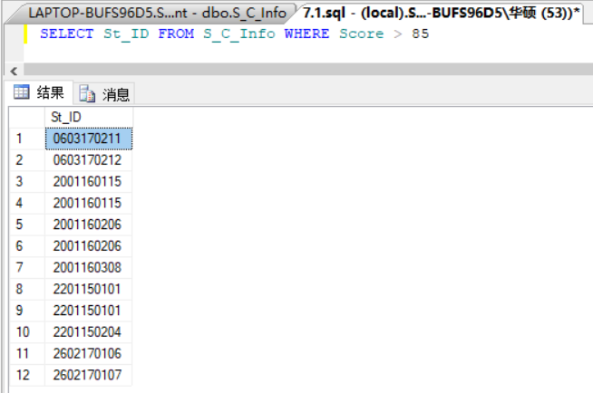

1.5

SELECT * FROM S_C_Info WHERE Score BETWEEN 70 AND 80

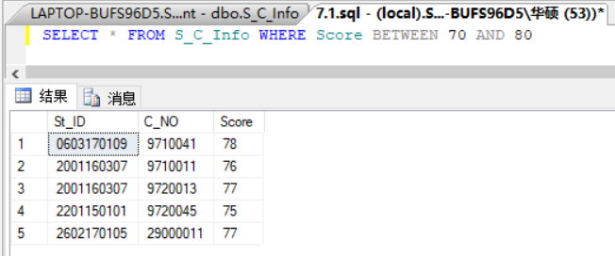

SELECT * FROM S_C_Info WHERE Score>70 AND Score<80

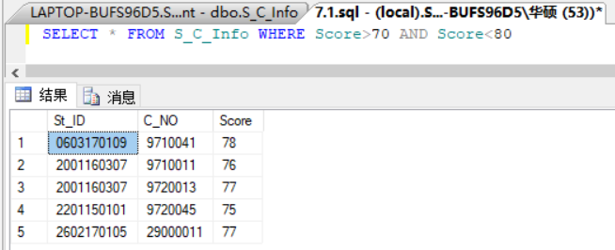

1.6

SELECT St_name, St_ID, St_sex FROM St_Info WHERE St_name LIKE '王%'

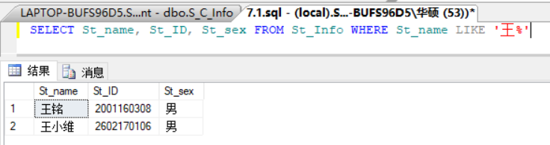

1.7

SELECT St_name, St_ID, St_sex, Cl_Name FROM St_Info WHERE Cl_Name LIKE '法学%'

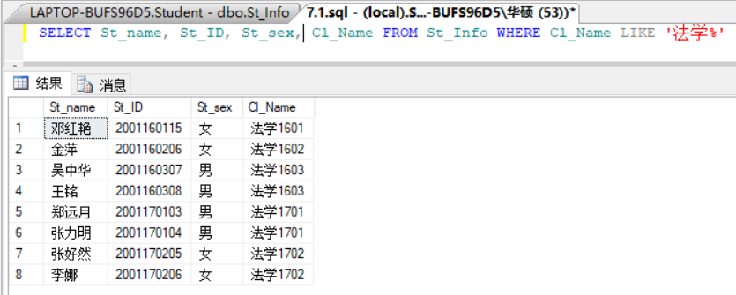

1.8

SELECT St_ID,Score FROM S_C_Info WHERE C_NO = 9710011 ORDER BY Score DESC

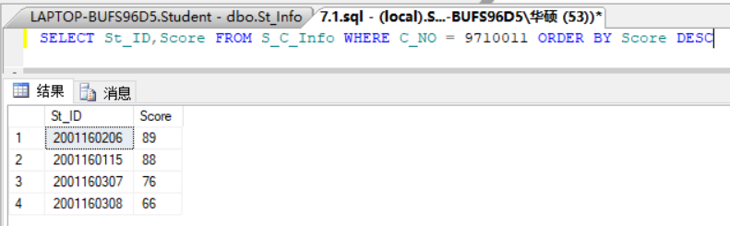

1.9

SELECT C_NO, C_type , C_credit FROM C_Info WHERE C_Name = '艺术设计史'

UNION ALL

SELECT C_NO, C_type , C_credit FROM C_Info WHERE C_Name = '民法学'

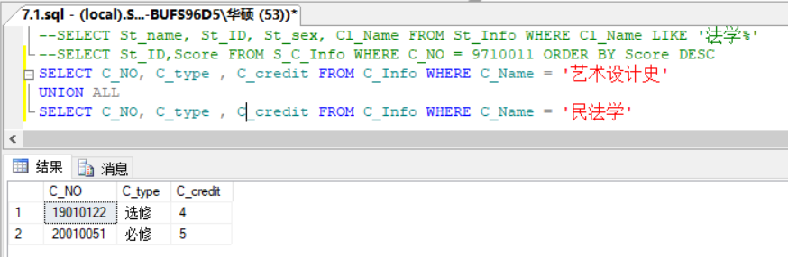

1.10

SELECT * INTO NEW FROM St_Info ORDER BY St_ID ASC

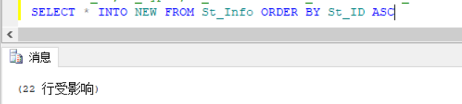

select * from dbo.NEW

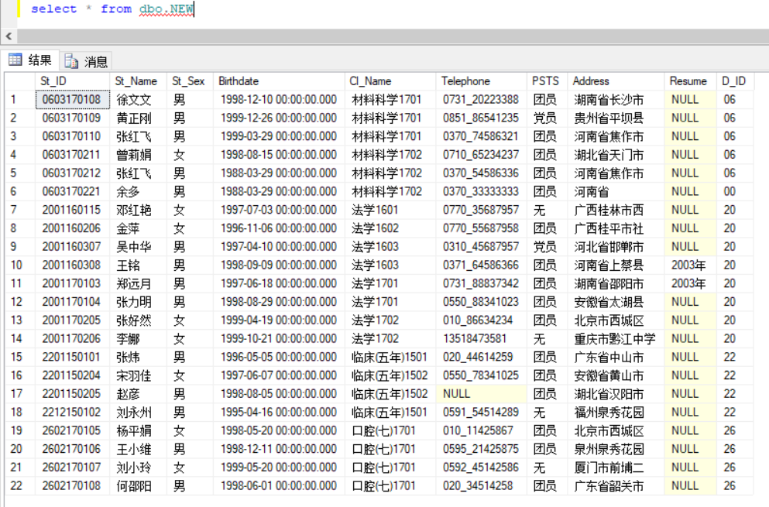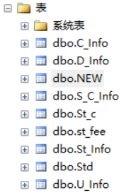

1.11

SELECT Cl_name, COUNT(Cl_name) AS 人数 FROM St_Info GROUP by Cl_Name

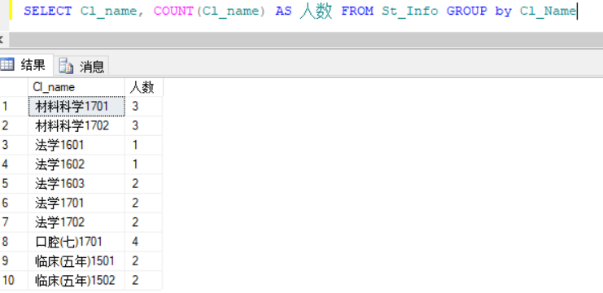

1.12

SELECT St_ID, Score FROM S_C_Info WHERE C_NO='29000011' COMPUTE AVG(Score)

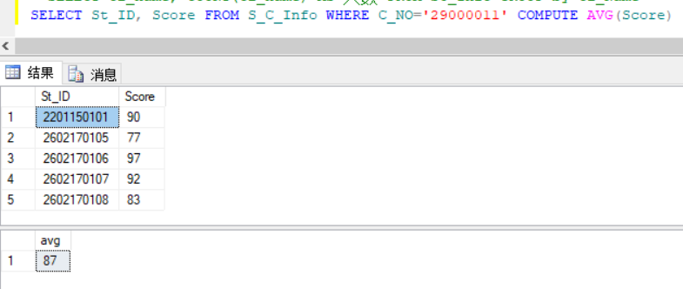

2.1

SELECT * from St_Info

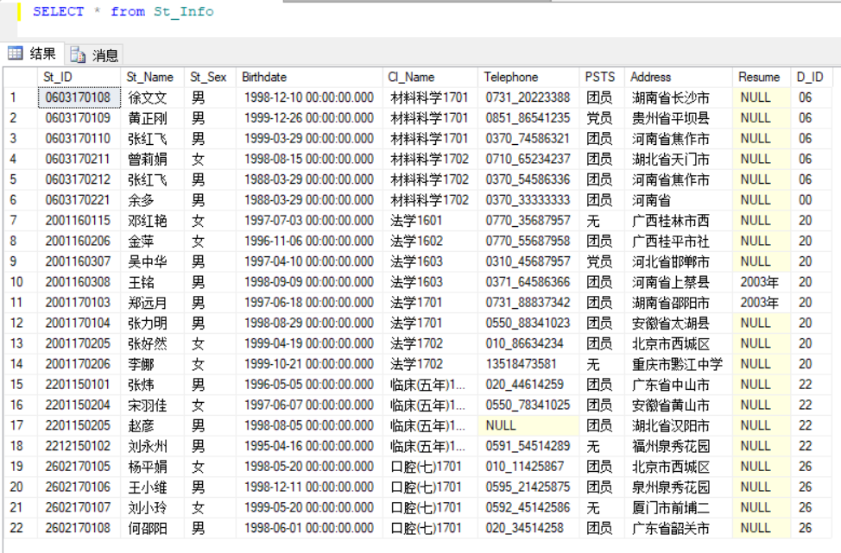

2.2

SELECT St_ID, St_Name, Birthdate from St_Info

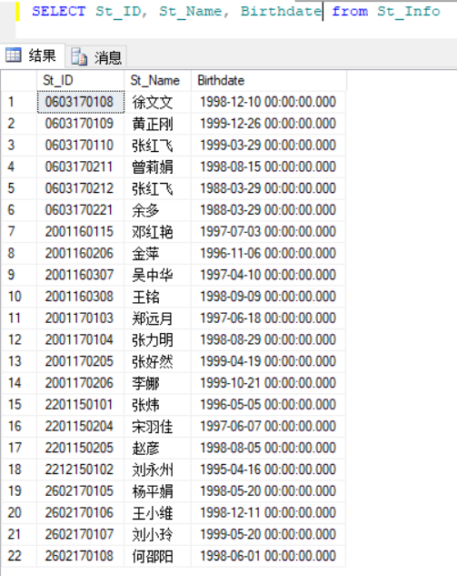

2.3

SELECT St_Name, Address from St_Info where St_ID = '2001160307'

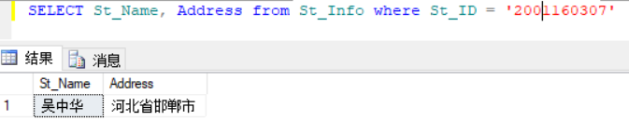

2.4

select St_ID, St_Name from St_Info where St_Sex = '男'

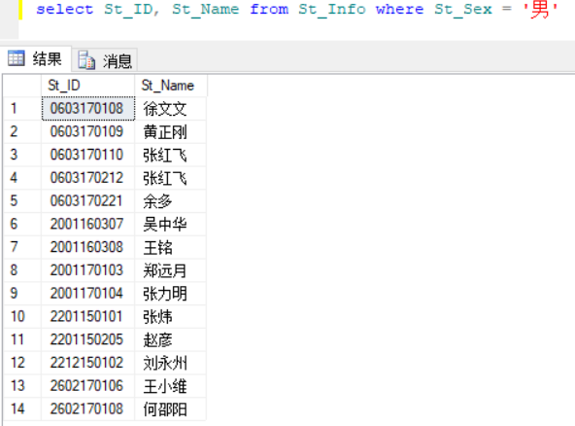

2.5

select St_ID, St_Name, Cl_Name from St_Info where Cl_Name = '材料科学'

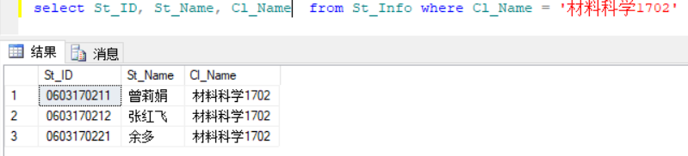

2.6

select * from C_Info where C_Credit=3 or C_Credit=4

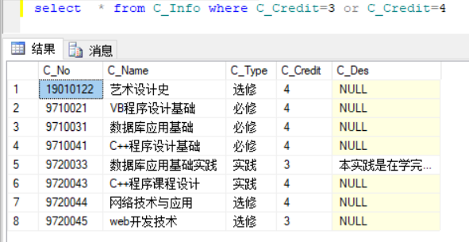

2.7

select C_NO 课程编号, AVG(Score) 平均成绩 from S_C_Info GROUP by C_NO

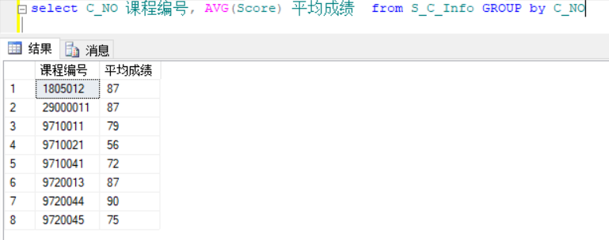

2.8

select St_ID, St_Name, St_Sex, Birthdate from St_Info where St_Name like '张%'

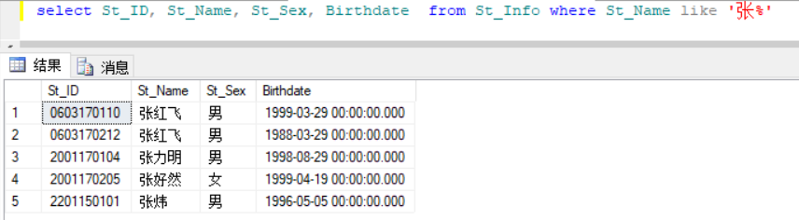

2.9

select MAX(YEAR(GETDATE())-YEAR(birthdate)) 最大年龄, MIN(YEAR(GETDATE())-YEAR(birthdate)) 最小年龄

from St_Info where Cl_Name like '%临床%'

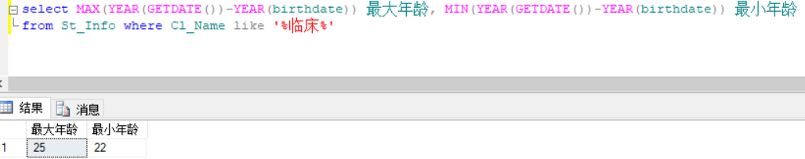

2.10

select St_ID,St_Name,Address from St_Info where Address like '%山%'

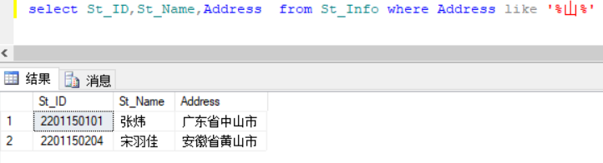

3.1

select COUNT(*) from St_Info

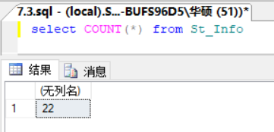

3.2

select SUBSTRING(St_Name,1,1) from St_Info

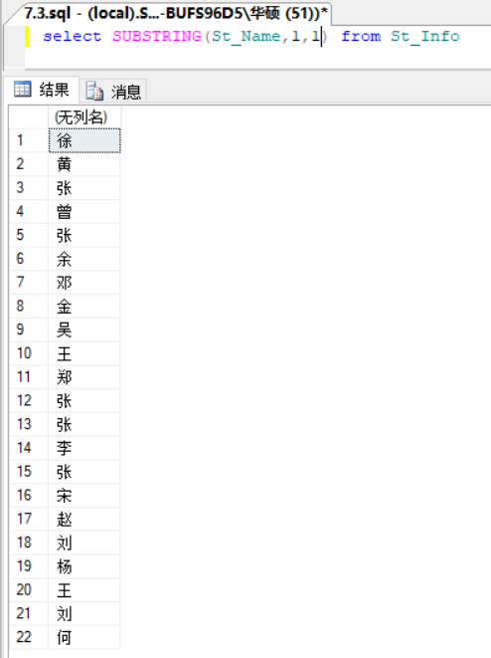

3.3

select YEAR(GETDATE()),MONTH(GETDATE()),DAY(GETDATE())

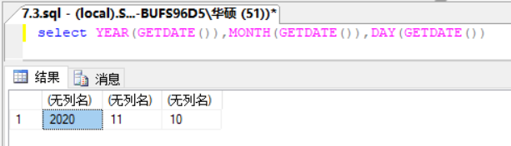

**实验八**

8.1.1

select * from St_Info where Cl_Name=(select Cl_Name from St_Info where St_Name = '杨平娟')

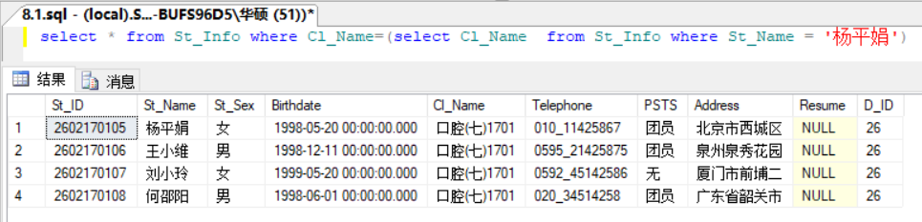

8.1.2

select St_ID,Score from S_C_Info where C_NO in (select C_NO from C_Info where C_Name = '体育')

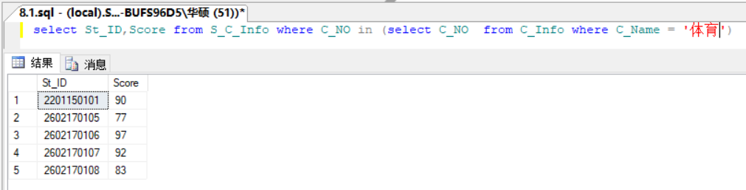

8.1.3

select St_ID,St_Name from St_Info where St_ID in (select St_ID from S_C_Info where C_NO in ('9710011','9710041'))

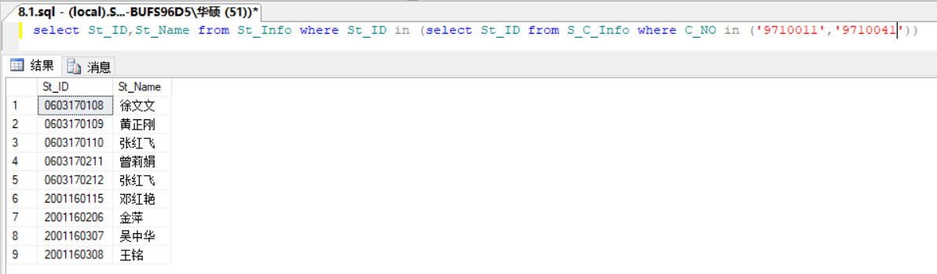

8.2.1

select St_ID,St_Name from St_Info where St_ID in (select St_ID from S_C_Info where Score >=92)

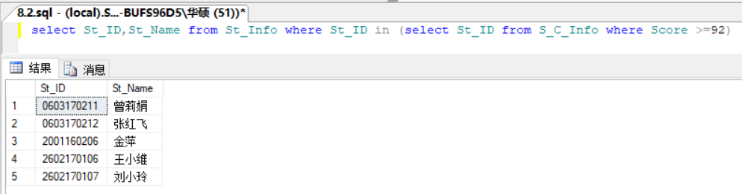

8.2.2

select * from S_C_Info where C_NO in (select C_NO from C_Info where C_Credit=4)

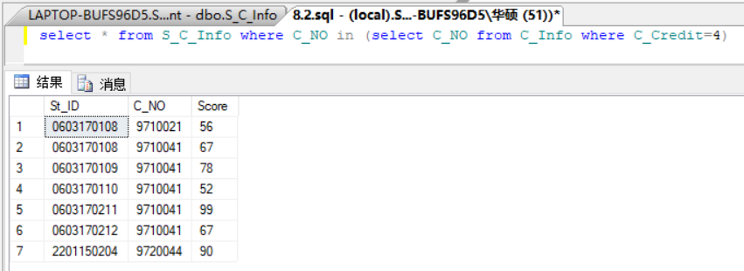

8.2.3

select St_Name, YEAR(GETDATE())-YEAR(Birthdate) as 年龄 from St_Info

where YEAR(GETDATE())-YEAR(Birthdate) > all(

select YEAR(GETDATE())-YEAR(Birthdate) from St_Info where Cl_Name = '法学')

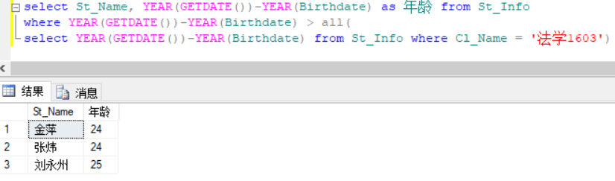

8.2.4

select St_ID,Score from S_C_Info where C_NO='9710041' and Score > any

(select Score from S_C_Info where C_NO = '29000011')

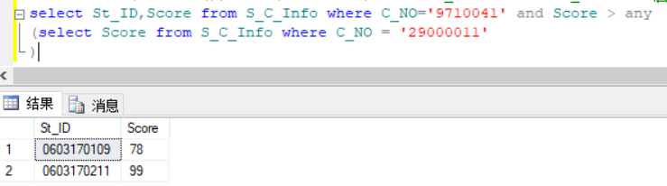

8.2.5

select St_Name,Cl_Name from St_Info where St_ID not in

(select St_ID from S_C_Info where C_NO = '9710041' or C_NO = '9710011')

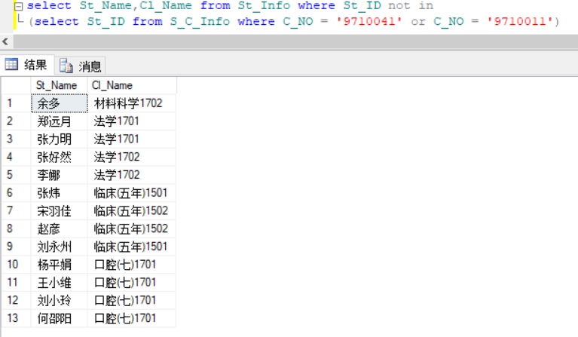

8.2.6

select C_NO,Score from S_C_Info where St_ID in

(select St_ID from St_Info where St_Name like '王%' )

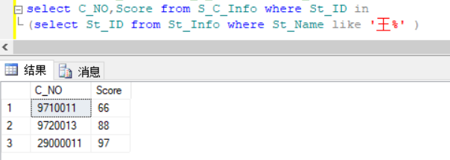

8.2.7

select St_ID,St_Name from St_Info where St_ID in

(select St_ID from S_C_Info

group by St_ID

having AVG(Score)>90)

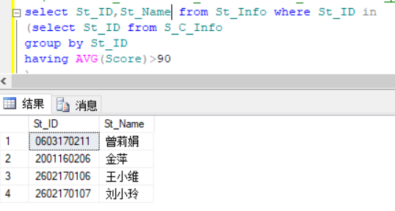

8.2.8

select C_No,C_Name from C_Info where C_No in

(select C_No from S_C_Info

group by C_NO

having COUNT(*)>=4)

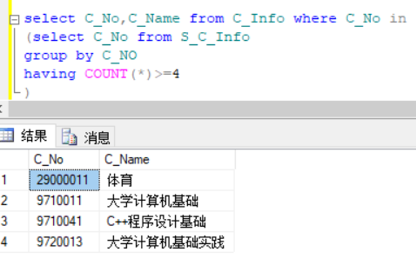

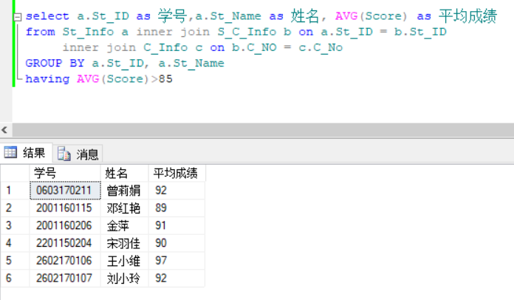

**第三次实验9-12**

**实验九**

9.1

9.1.1

select x.St_ID,x.St_Name,y.Score

from St_Info x,S_C_Info y

where x.St_ID=y.St_ID and y.Score between 70 and 80

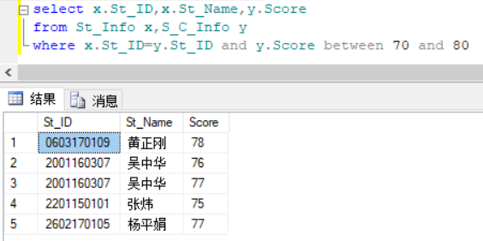

9.1.2

select x.St_ID,x.St_Name,y.Score

from St_Info x,S_C_Info y,C_Info z

where x.St_ID=y.St_ID and y.C_NO = z.C_No and z.C_Name = 'C++程序设计基础'

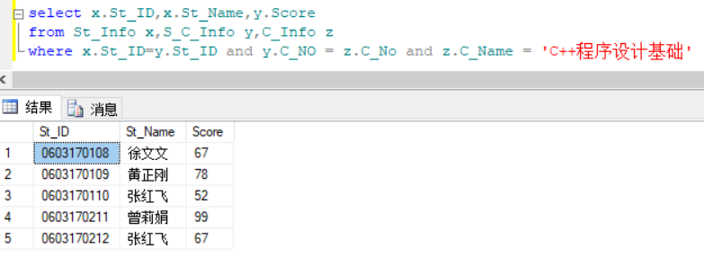

9.1.3

select x.St_ID,x.St_Name,z.C_Name, y.Score

from St_Info x,S_C_Info y,C_Info z

where x.St_ID=y.St_ID and y.C_NO = z.C_No and y.Score<60

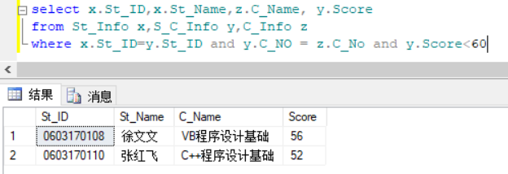

9.2

9.2.1

select st.St_ID,st.St_Name,c.C_Name, sc.Score

from St_Info st join S_C_Info sc on st.St_ID=sc.St_ID join C_Info c on sc.C_NO=c.C_No

where Cl_Name like '法学%'

order by st.St_ID

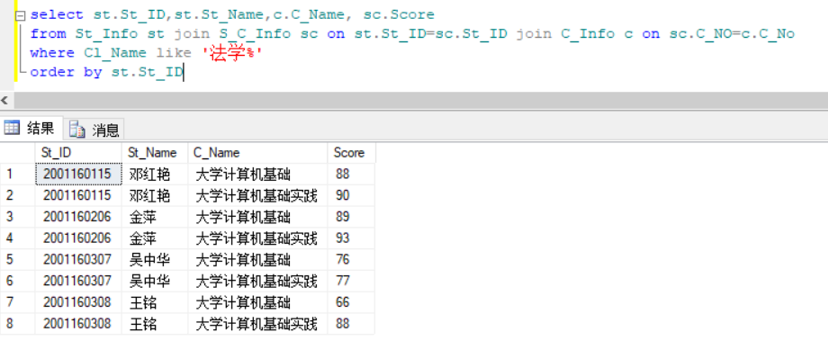

9.2.2

select C_Name as 课程名称, MAX(Score) as 最高分

from S_C_Info sc join C_Info c on sc.C_NO=c.C_No

group by C_Name

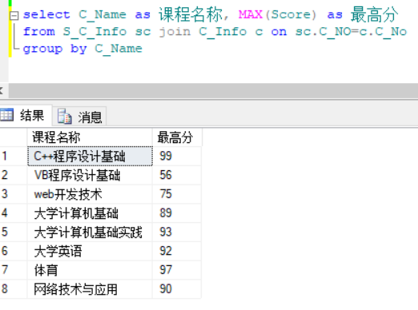

9.2.3

select a.C_No,a.C_Name,b.St_ID,b.Score

from C_Info a left outer join S_C_Info b on a.C_No = b.C_NO

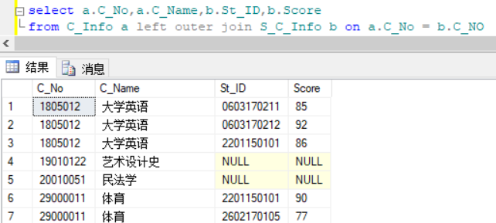

9.2.4

select a.C_No,a.C_Name,b.St_ID,b.Score

from C_Info a right outer join S_C_Info b on a.C_No = b.C_NO

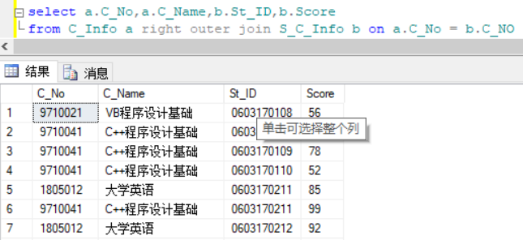

9.2.5

select a.C_No,a.C_Name,b.St_ID,b.Score

from C_Info a full outer join S_C_Info b on a.C_No = b.C_NO

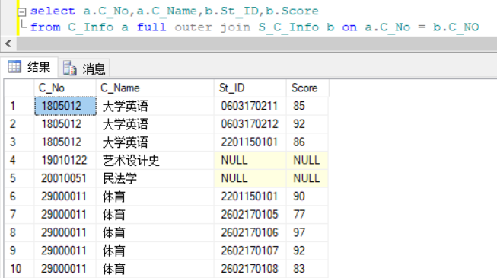

9.2.6

select a.St_ID as 学号,a.St_Name as 姓名, AVG(Score) as 平均成绩

from St_Info a inner join S_C_Info b on a.St_ID = b.St_ID

inner join C_Info c on b.C_NO = c.C_No

GROUP BY a.St_ID, a.St_Name

having AVG(Score)>85

我的表中张红飞平均分没有大于85

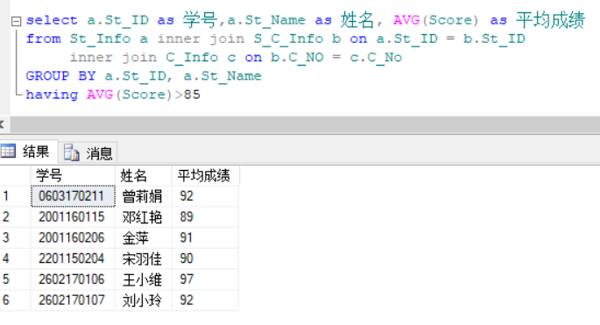

9.3

select c.C_No,c.C_Name,c.C_Credit,a.St_Name,b.Score

from St_Info a inner join S_C_Info b on a.St_ID = b.St_ID

inner join C_Info c on b.C_NO = c.C_No

where c.C_Type='必修'

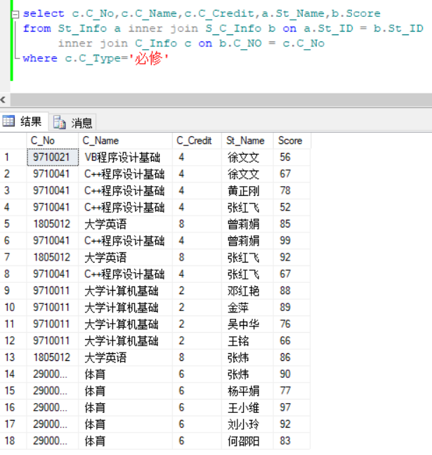

9.4

select a.St_ID 学号,a.St_Name 姓名,max(b.Score) as 分数

into newtem

from St_Info a inner join S_C_Info b on a.St_ID = b.St_ID

group by a.St_ID,a.St_Name

go

select distinct a.学号,a.姓名,b.C_NO 课程编号,a.分数

from newtem a left outer join S_C_Info b on (a.分数 = b.Score and a.学号 = b.St_ID)

drop table newtem

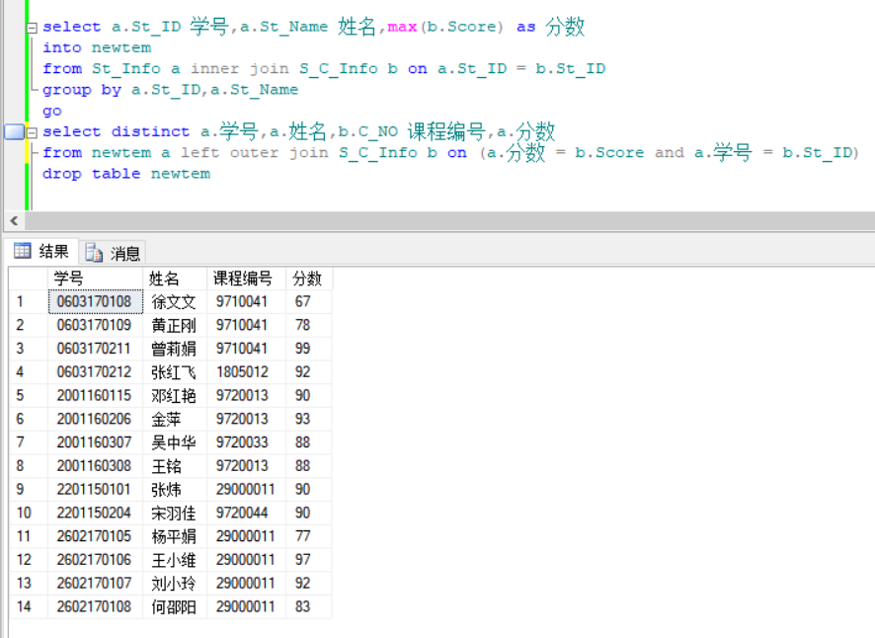

9.5

select st.St_ID 学号,st.St_Name 姓名,SUM(sc.Score) 总成绩

from St_Info st left outer join S_C_Info sc on st.St_ID = sc.St_ID

group by st.St_ID,st.St_Name

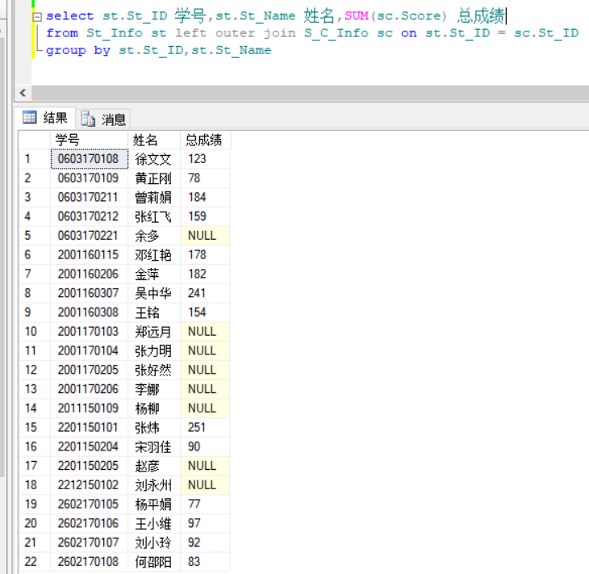

9.6

select a.St_ID 学号,a.St_Name 姓名, c.C_Name 课程名称,b.Score as 分数

from St_Info a inner join S_C_Info b on a.St_ID = b.St_ID inner join C_Info c on b.C_NO=c.C_No

where a.St_Sex = '男'

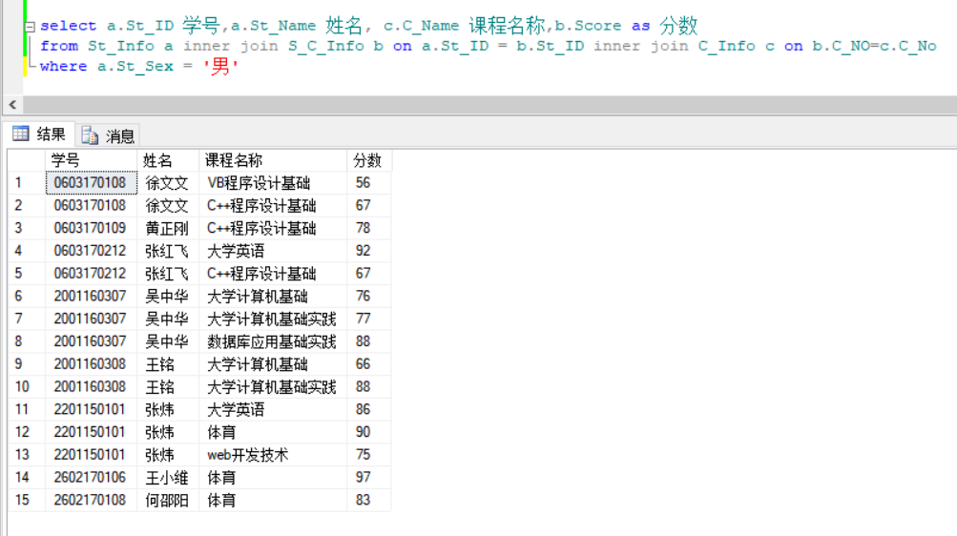

**实验10**

10.1.1

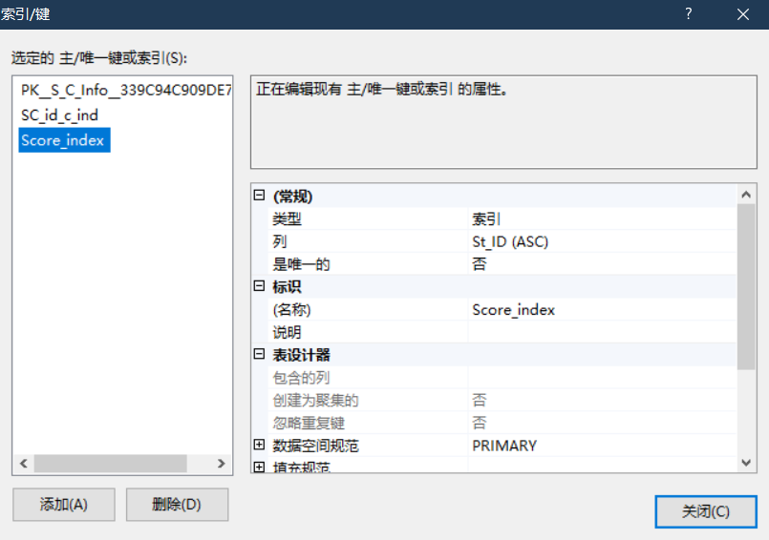

10.1.2

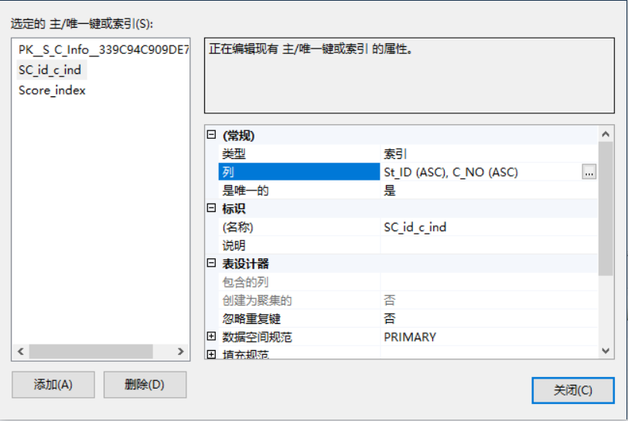

10.2

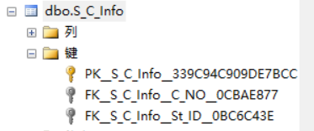

10.3

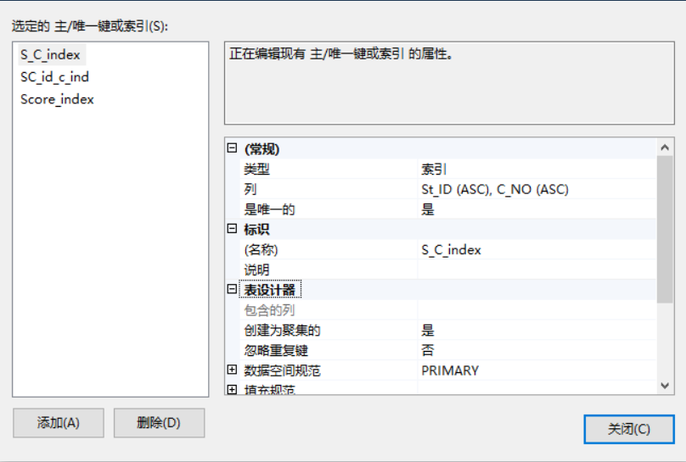

10.4

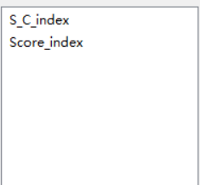

10.5.1

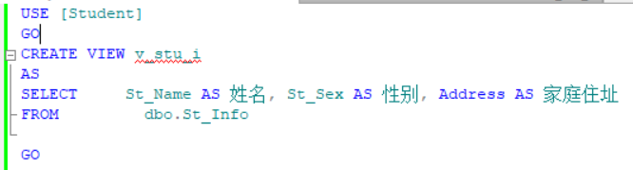

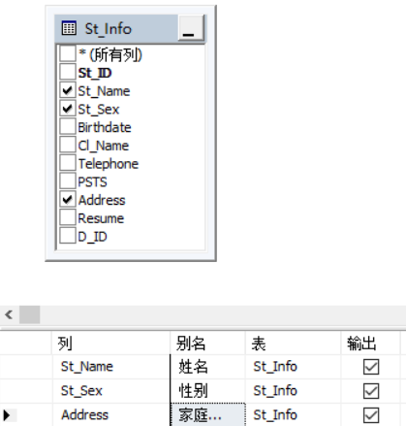

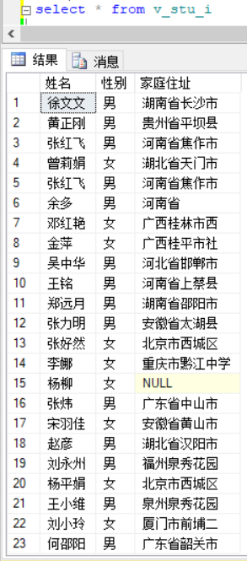

10.5.2

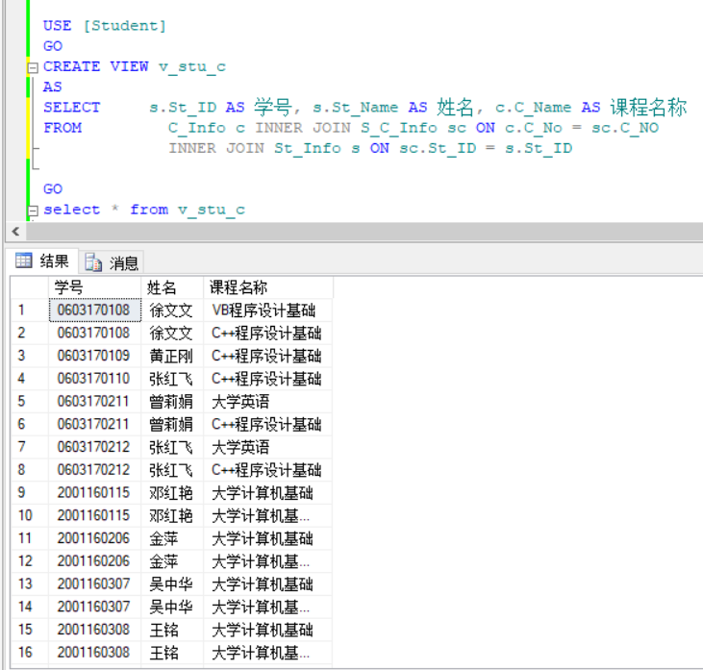

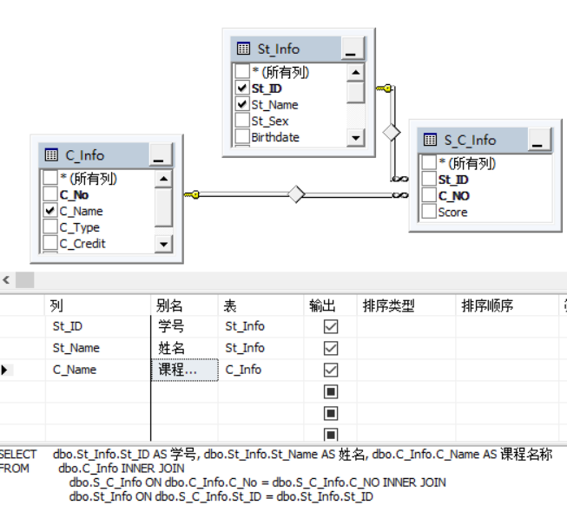

10.5.3

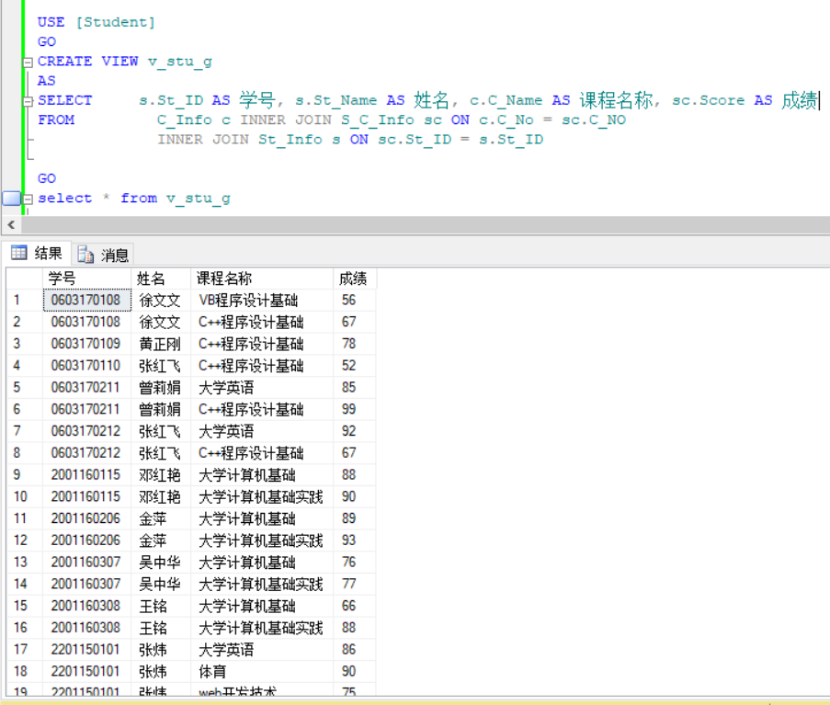

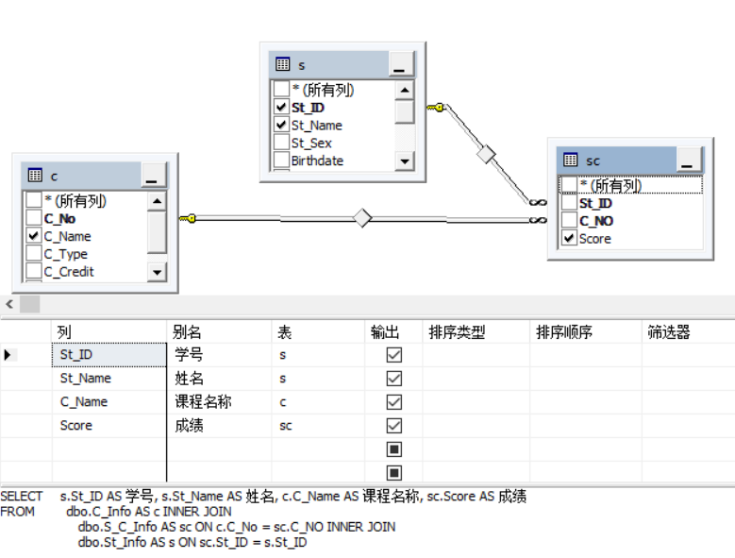

10.6.1

select * from v_stu_g where 学号 = '2001160308'

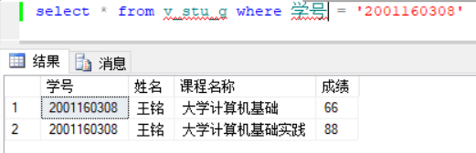

10.6.2

select * from v_stu_c where 课程名称 = '体育'

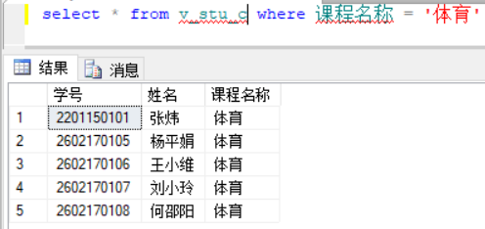

10.7

use Student

go

create view v_stu_a

AS

select * from S_C_Info

where St_ID = '2001160307'

go

select * from v_stu_a

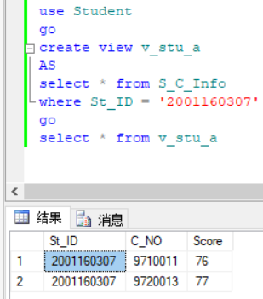

10.8

use Student

go

create view v_Count

AS

select St_Info.St_Sex,COUNT(*) as 人数

from St_Info,D_Info

where St_Info.D_ID = D_Info.D_ID and D_Info.D_Name ='材料科学与工程学院'

group by St_Sex

go

select * from v_Count

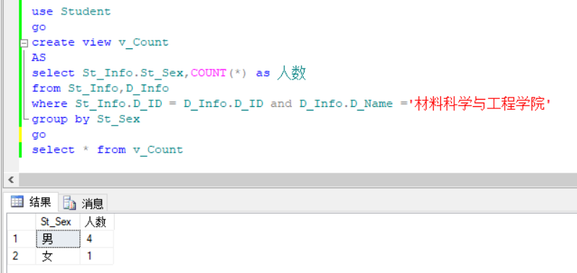

10.9

use Student

go

create view v_stu_m

AS

select a.St_ID 学号,St_Name 姓名,SUM(C_Credit) 总学分

from St_Info a join S_C_Info b on a.St_ID = b.St_ID join C_Info c on c.C_No = b.C_NO

where b.Score>=60

group by a.St_ID,St_Name

go

select * from v_stu_m

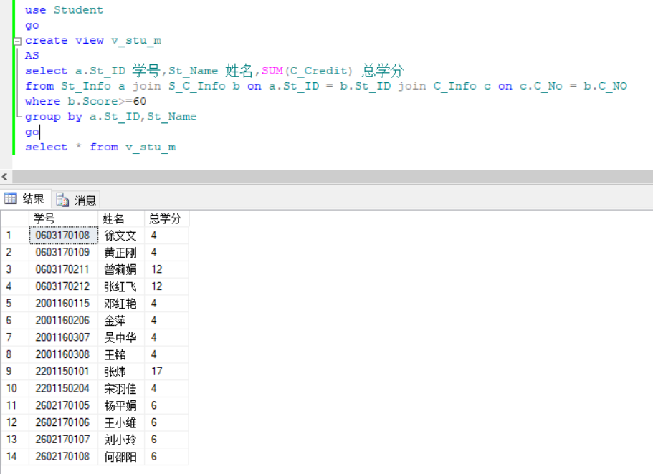

10.10

select * from v_stu_m where 总学分>10

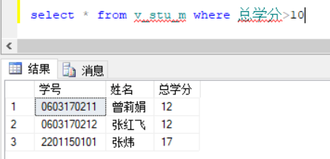

张红飞多了一门课程（之前操作未删除）

10.11

drop view v_stu_c,v_stu_g

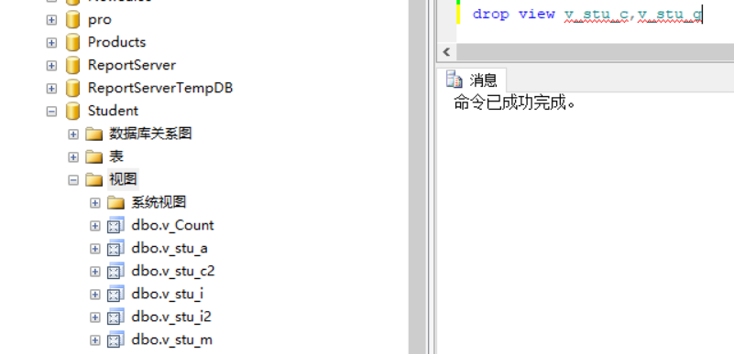

10.12

use Student

go

alter view v_stu_i

as

select St_ID 学号,St_Name 姓名,St_Sex 性别,PSTS 政治面貌

from St_Info

go

select * from v_stu_i

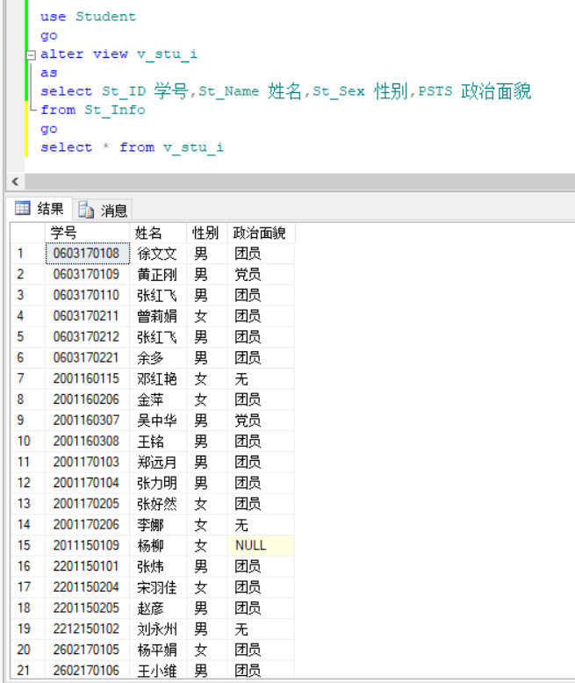

**实验11**

11.1

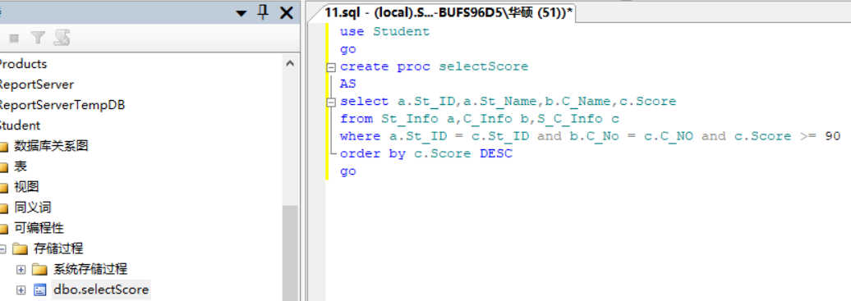

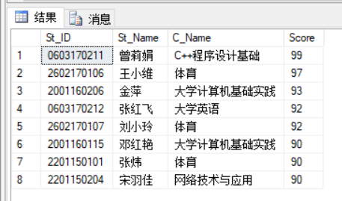

11.2

use Student

go

create proc cCount

AS

select COUNT(C_No) as 课程门数 from C_Info

go

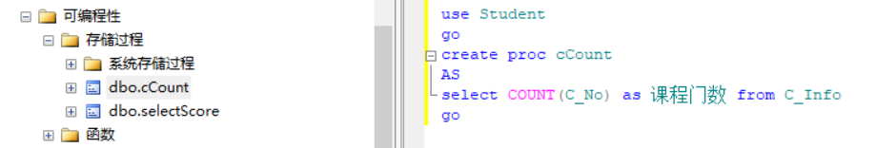

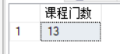

11.3

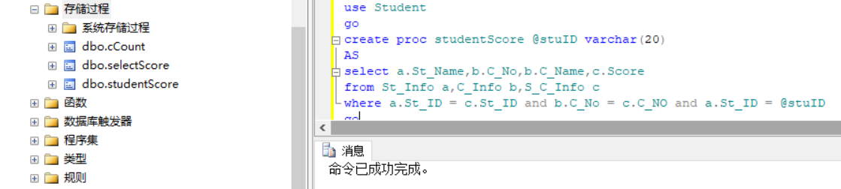

sp_help studentScore

go

sp_helptext studentScore

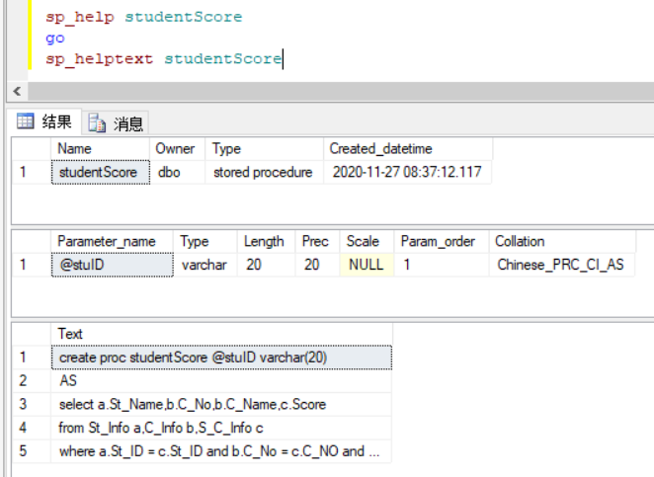

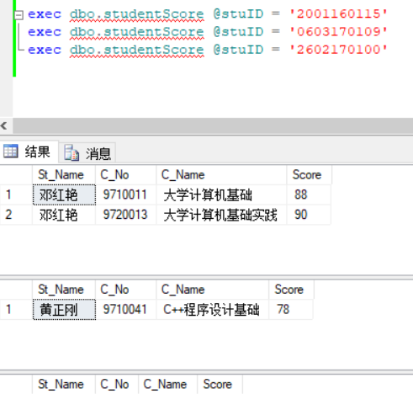

use Student

go

alter proc studentScore @stuID varchar(20) ='*'

AS

if(@stuID='*')

begin

select a.St_Name,b.C_No,b.C_Name,c.Score

from St_Info a,C_Info b,S_C_Info c

where a.St_ID = c.St_ID and b.C_No = c.C_NO

end

else

begin

select a.St_Name,b.C_No,b.C_Name,c.Score

from St_Info a,C_Info b,S_C_Info c

where a.St_ID = c.St_ID and b.C_No = c.C_NO and a.St_ID = @stuID

end

Go

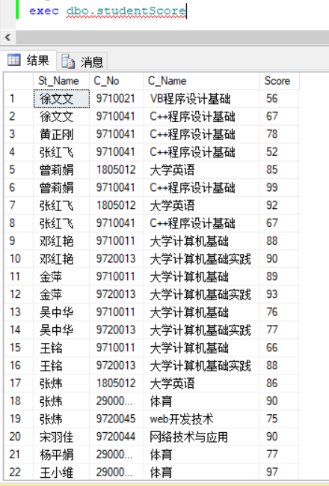

11.4

use Student

go

create proc stdCCnt @Cnt int

AS

select a.St_ID 学号,St_Name 姓名,COUNT(*) 课程门数

from St_Info a join S_C_Info b on a.St_ID = b.St_ID

group by a.St_ID,St_Name

having COUNT(*) = @cnt

go

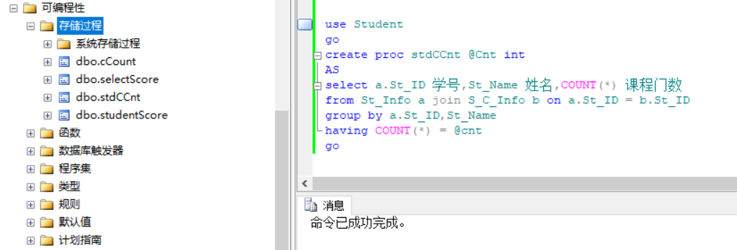

exec dbo.stdCCnt 2

exec dbo.stdCCnt @Cnt = 2

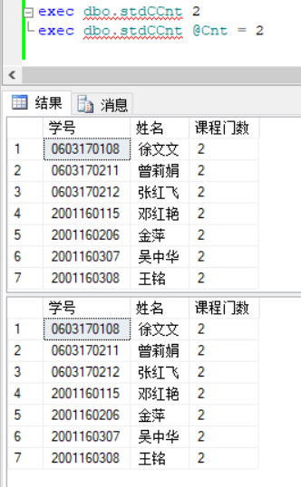

11.5

use Student

go

create proc insertCinfo @cno char(10), @cname varchar(30), @ccredit tinyint

AS

insert into C_Info values (@cno,@cname,'',@ccredit,'')

go

use Student

go

create proc updataCinfo @cno char(10), @cname varchar(30),@ctype char(4) ='必修',@ccredit tinyint

AS

update C_Info set C_Name = @cname,C_Type = @ctype,C_Credit = @ccredit where C_No = @cno

go

use Student

go

create proc deletCinfo @cno char(10)

AS

delete C_Info where C_No = @cno

go

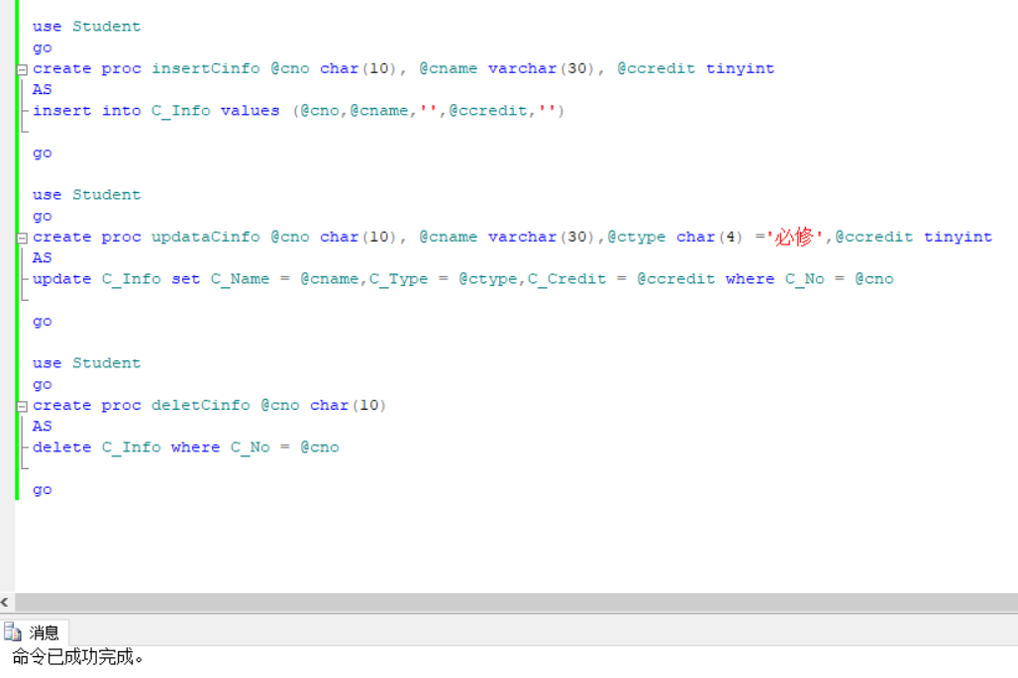

11.6

use Student

go

create proc stdDname @sname char(10),@dname char(30) output

as

select @dname = D_name

from St_Info a join D_Info b on a.D_ID = b.D_ID

where a.St_Name = @sname

go

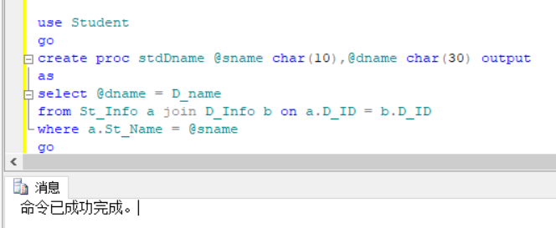

declare @getdname char(30)

exec dbo.stdDname '吴中华',@getdname output

select @getdname 学院名称

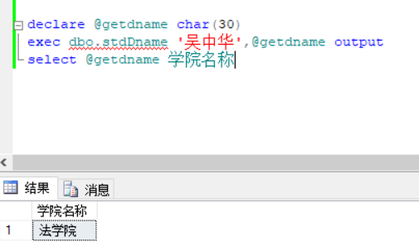

11.7.1

use Student

go

create proc getPractise @dname varchar(30)

as

select st.St_ID 学号, st.St_Name 姓名, c.C_No 课程编号, c.C_Name 课程名称

from St_Info st join S_C_Info sc on st.St_ID = sc.St_ID join C_Info c on sc.C_NO=c.C_No join D_Info d on st.D_ID=d.D_ID

where d.D_name=@dname and c.C_Type = '实践'

go

11.7.2

exec dbo.getPractise @dname = '法学院'

exec dbo.getPractise @dname = '材料科学与工程学院'

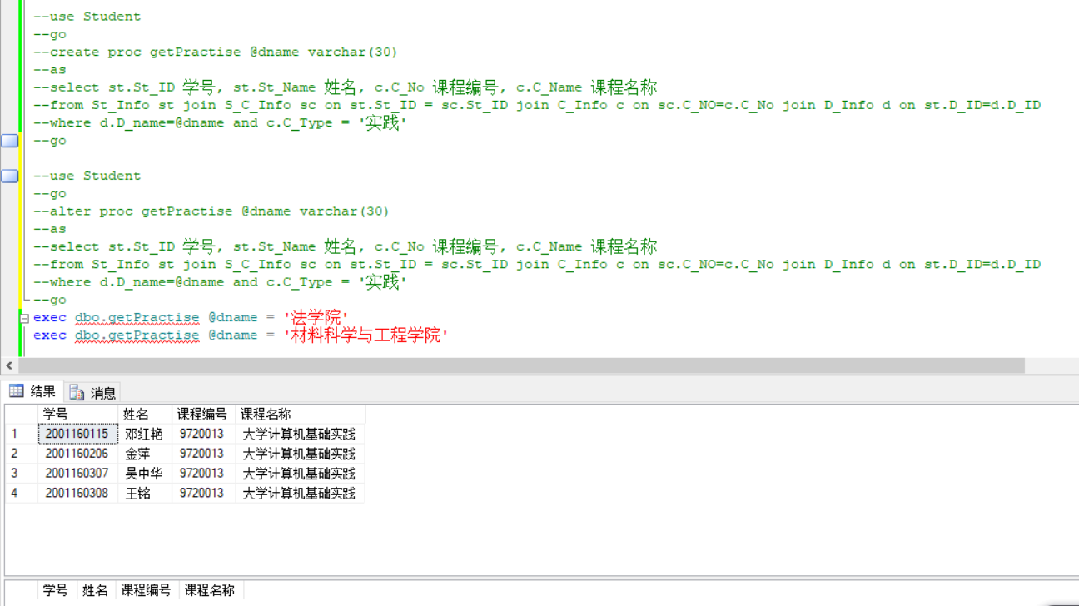

11.7.3

sp_rename 'getPractise','getPctStu'

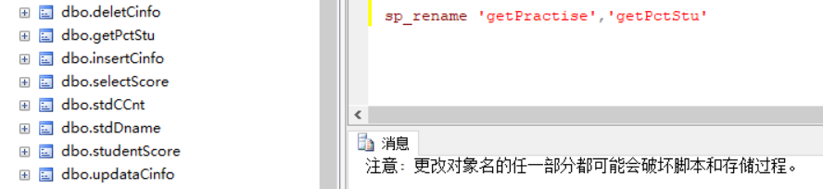

11.7.4

create proc getPctStu @dname varchar(30),@stuCount int output

as

select @stuCount = count(c.C_Name)

from St_Info st join S_C_Info sc on st.St_ID = sc.St_ID join C_Info c on sc.C_NO=c.C_No join D_Info d on st.D_ID=d.D_ID

where d.D_name=@dname and c.C_Type = '实践'

declare @i int

declare @return int

exec @i = dbo.getPctStu '法学院', @return output

select @return as 人数

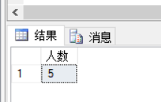

create proc getPctStu @dname varchar(30),@stuCount int output

as

select @stuCount = COUNT(St_ID) from St_Info where St_ID in(

select distinct st.St_ID 学号

from St_Info st join S_C_Info sc on st.St_ID = sc.St_ID join C_Info c on sc.C_NO=c.C_No join D_Info d on st.D_ID=d.D_ID

where d.D_name=@dname and c.C_Type = '实践')

declare @i int

declare @return int

exec @i = dbo.getPctStu '法学院', @return output

select @return as 人数

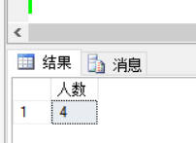

11.7.5

create proc getPctStu @dname varchar(30),@stuCount int output

as

if(@dname in (select D_Name from D_Info))

begin

select @stuCount = COUNT(St_ID) from St_Info where St_ID in(

select distinct st.St_ID 学号

from St_Info st join S_C_Info sc on st.St_ID = sc.St_ID join C_Info c on sc.C_NO=c.C_No join D_Info d on st.D_ID=d.D_ID

where d.D_name=@dname and c.C_Type = '实践')

return 0

end

else

begin

print'院系不存在'

return -1

end

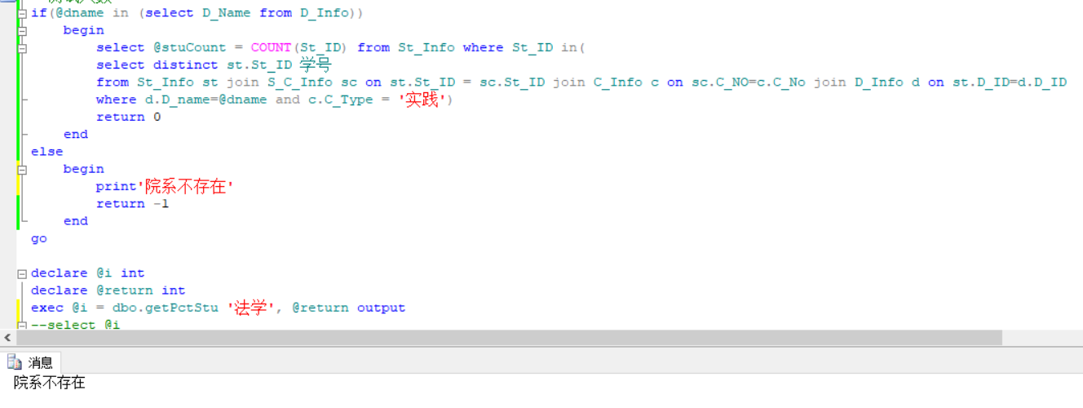

11.7.6

sp_helptext getPctStu

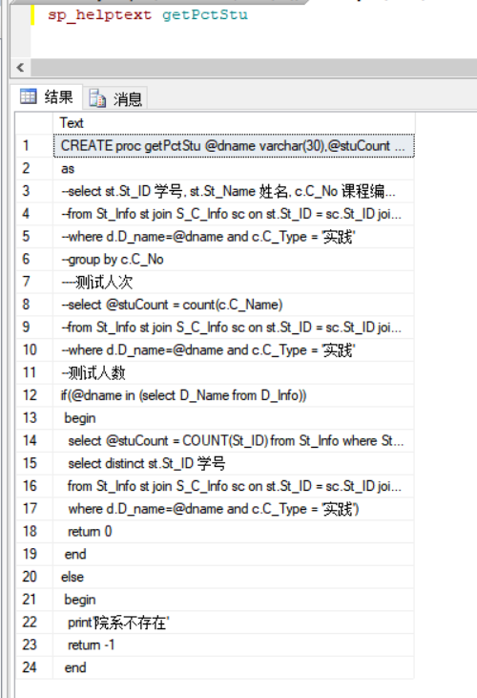

11.7.7

drop proc getPctStu

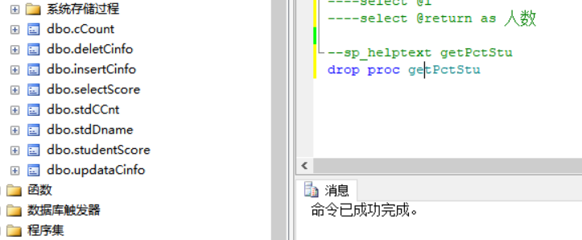

**实验12**

12.1

CREATE TRIGGER tr_AutoSetType on C_Info for insert

AS

BEGIN

update C_Info set C_Type = '必修'

END

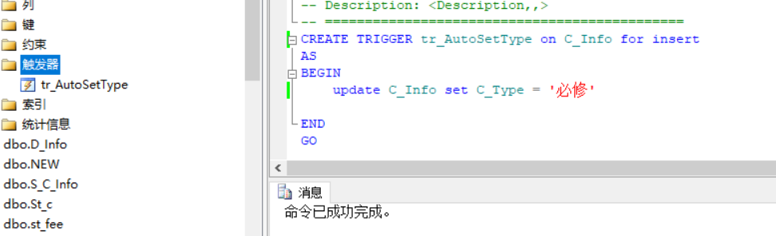

insert into C_Info(C_No,C_Name,C_Credit)values('82021','数据库原理','2')

go

select * from C_Info

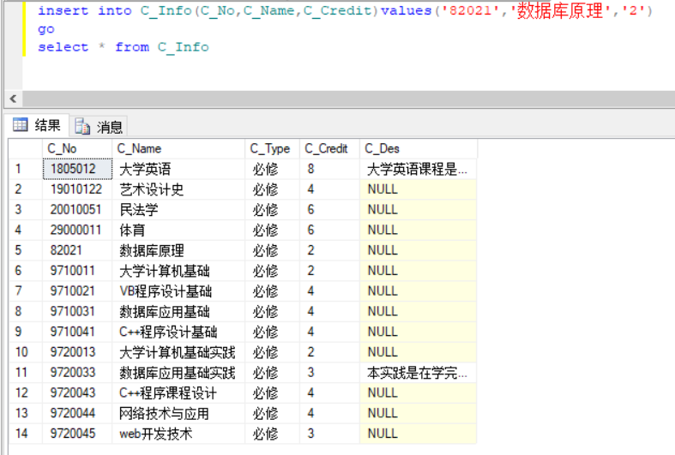

12.2

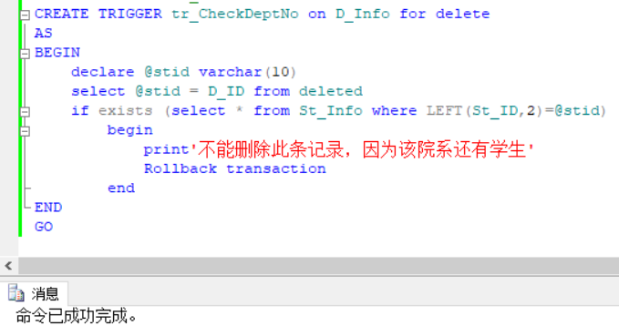

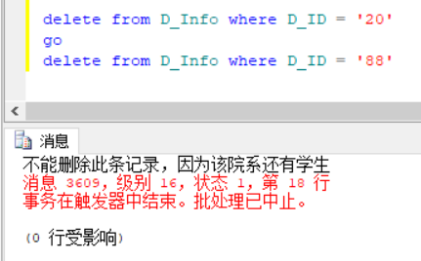

12.3

CREATE TRIGGER tr_CheckStID on St_Info for insert,update

AS

BEGIN

declare @stid varchar(10)

select @stid = D_ID from inserted

if not exists (select * from D_Info where D_ID =LEFT(@stid,2))

begin

print'无此学院，不能输入这样的学号'

Rollback transaction

end

END

GO

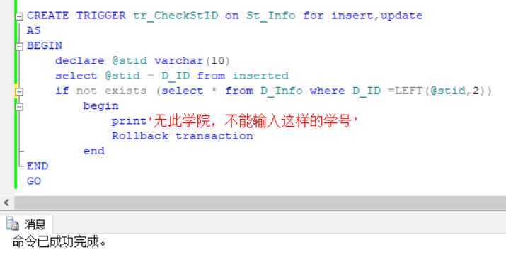

insert into St_Info(St_ID,St_Name)values('2701160101','张星')

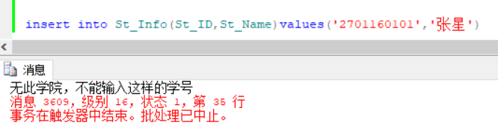

12.4

create trigger tr_CheckStIDandCNo on s_c_info for insert as

begin

declare @sid char(10)

declare @cno char(10)

select @sid = st_id from inserted

select @cno = c_no from inserted

if ((not exists(select * from St_Info where St_ID=@sid)) or (not exists(select * from C_Info where C_No = @cno)))

begin

print'不能插入无学号或无课程的成绩记录'

Rollback transaction

end

end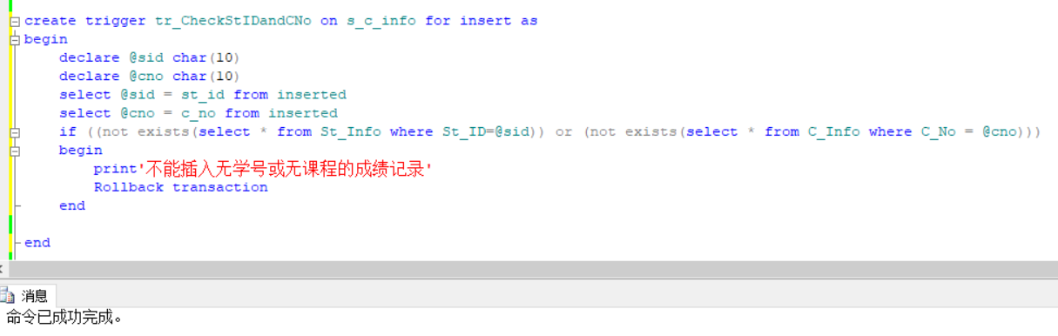

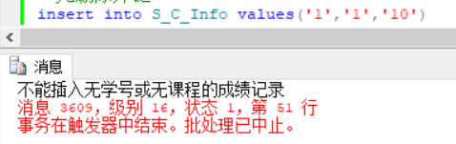

12.5

create trigger tr_AutoDelete on st_info for delete as

begin

delete S_C_Info where St_ID in(select St_ID from deleted)

end

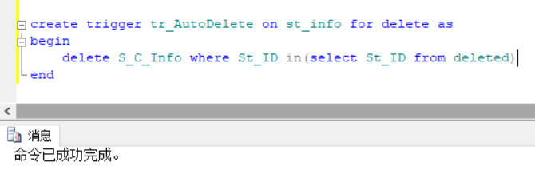

delete from St_Info where St_ID = '0603170110'

删除前

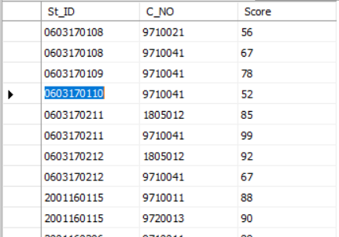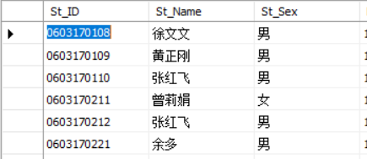

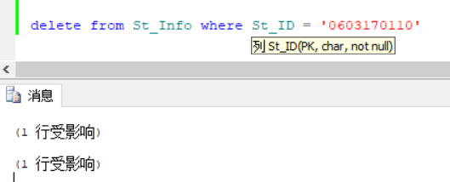

删除后

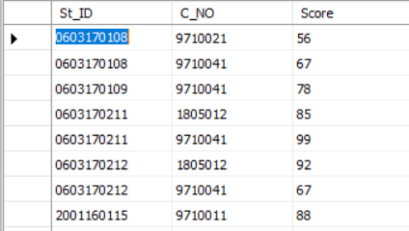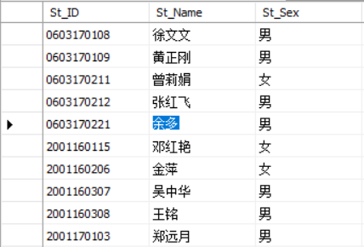

12.6

sp_helptext tr_autodelete

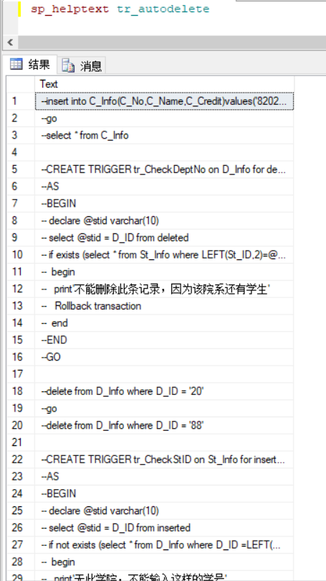

12.7

sp_rename tr_autodelete,tr_autodelete2

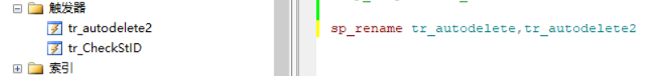

12.8

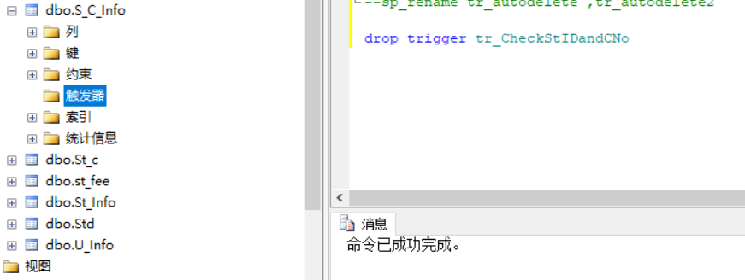

**实验15**

1.

1.1

Private Sub Form1_Click(sender As Object, e As EventArgs) Handles Me.Click

Dim i1 As Integer, a2 As Double, s3 As String, b4 As Boolean

i1 = 123.45

a2 = 123.45

s3 = "123.45"

b4 = True

Label1.Text = i1

Label2.Text = a2

Label3.Text = s3

Label4.Text = b4

End Sub

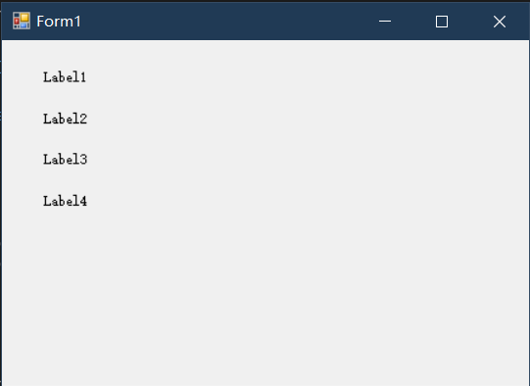

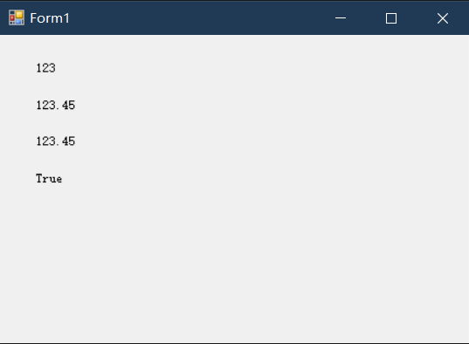

1.2

Private Sub Form1_Click(sender As Object, e As EventArgs) Handles Me.Click

Label1.Text = DateTime.Now

Label2.Text = Now.ToString("yyyy-mm-dd")

Label3.Text = DateTime.Today

Label4.Text = Now.Hour

End Sub

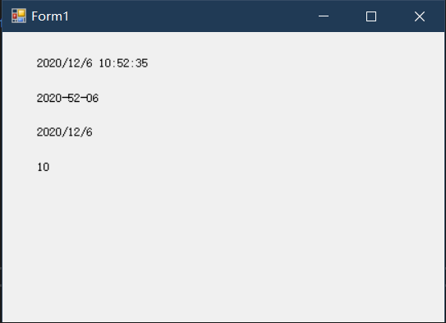

1.3

Private Sub Form1_Click(sender As Object, e As EventArgs) Handles Me.Click

Dim i1 As Integer, a2 As Double, s3 As String, b4 As Boolean

i1 = 123.45

a2 = 123.45

s3 = "123.45"

b4 = True

Label1.Text = i1 ^ 2 + Math.Sqrt(a2) + s3

Label2.Text = i1 & a2 & s3

Label3.Text = Rnd()

Label4.Text = "生成10~20的随机数:" & Int((20 - 10 + 1) * Label3.Text + 10)

End Sub

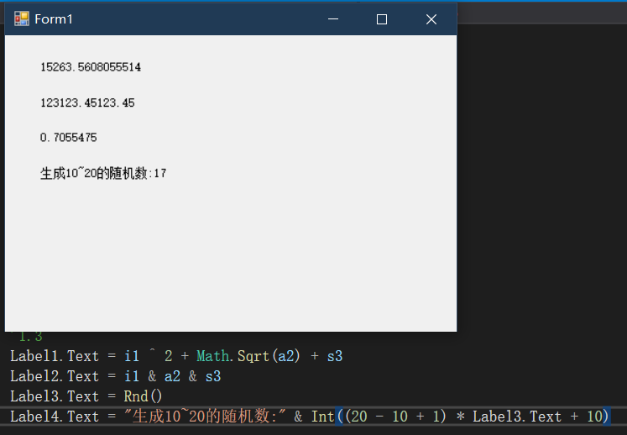

2.

2.1

Private Sub _max_Click(sender As Object, e As EventArgs) Handles Me.Click

Dim x As Integer, y As Integer, z As Integer, max As Integer

x = InputBox("输入整数x:", "输入")

y = InputBox("输入整数y:", "输入")

z = InputBox("输入整数z:", "输入")

If (x > y) Then

max = x

Else

max = y

End If

If (max < z) Then

max = z

End If

MsgBox(x & "," & y & "," & z & "中的最大值为：" & max, , "求最大值")

End Sub

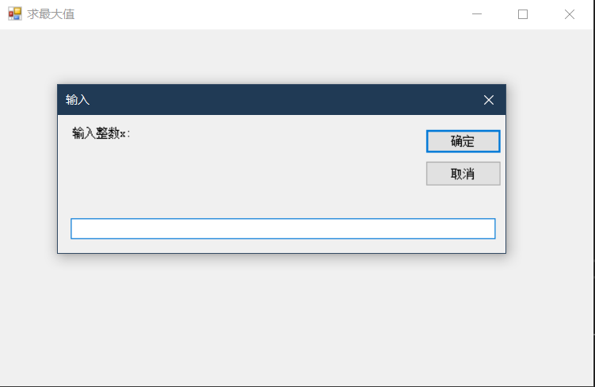

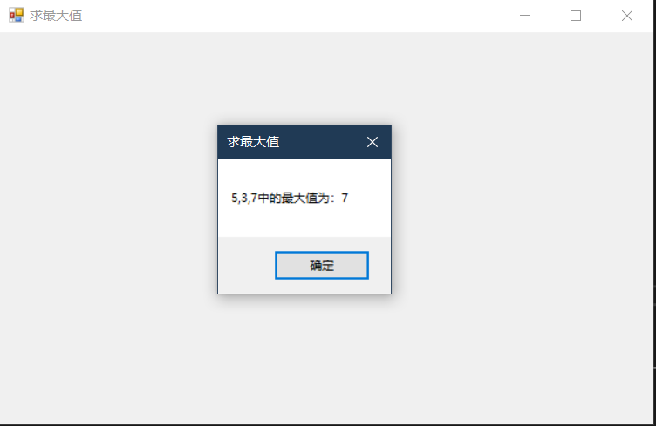

3.

3.1

Function cal_cost(dis As String, weight As String) As Double

Dim i_dis As Integer, i_weight As Integer

Dim i_cost As Double

i_dis = Val(dis)

i_weight = Val(weight)

Select Case i_dis

Case 0 To 50

i_cost = i_weight * i_dis

Case 51 To 1000

i_cost = 50 * i_weight + 1.1 * i_weight * (i_dis - 50)

Case Is > 1000

i_cost = 0.95 * (50 * i_weight + 1.1 * i_weight * (i_dis - 50))

Case Else

MsgBox("请输入数字",, "输入错误")

End Select

Return i_cost

End Function

Private Sub TextBox3_MouseClick(sender As Object, e As MouseEventArgs) Handles TextBox3.MouseClick

TextBox3.Text = Trim(Str(cal_cost(TextBox1.Text, TextBox2.Text)))

End Sub

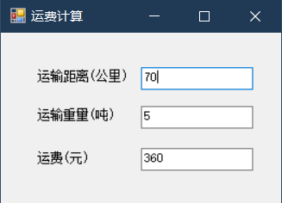

4.

Function n_n(nn As String) As Integer

Dim result As Integer, n As Integer, i As Integer

result = 1

n = Val(nn)

If (n = 0) Then

Return 0

End If

For i = 2 To n Step 1

result = i * result

Next i

Return result

End Function

Private Sub Label2_Click(sender As Object, e As EventArgs) Handles Label2.Click

TextBox2.Text = Trim(Str(n_n(TextBox1.Text)))

End Sub

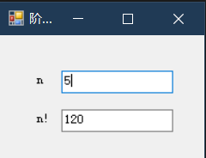

5.

Private Sub five_Click(sender As Object, e As EventArgs) Handles Me.Click

Dim a(10) As Integer, i As Integer, min As Integer

For i = 0 To 9 Step 1

a(i) = InputBox("请输入", "输入")

Next

min = a(0)

For i = 1 To 9 Step 1

If (a(i) < min) Then

min = a(i)

End If

Next

MsgBox("十个数中的最小值为：" & min,, "最小值")

End Sub

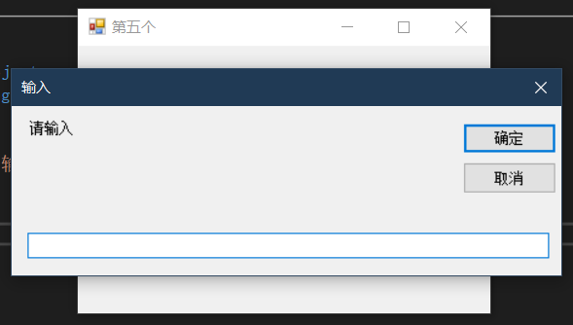

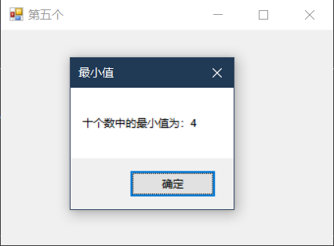

6.

Private Sub Button1_Click(sender As Object, e As EventArgs) Handles Button1.Click

Dim n As Integer， str As String

If (TextBox1.Text <= 0 Or TextBox1.Text - CInt(TextBox1.Text) <> 0) Then

Label1.Text = "请输入正整数"

Else

Label1.Text = ""

n = TextBox1.Text

For i = 1 To n

str = Space(2 * n - 2 * i)

For j = 1 To i

str = str & Space(1) & i

Next j

Label1.Text = Label1.Text & str & vbCrLf

Next i

End If

End Sub

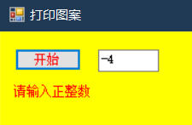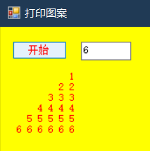

Text

Backcolor

Forecolor

**实验16**

1.

Public Class test1

Private Sub ComboBox1_SelectedIndexChanged(sender As Object, e As EventArgs) Handles ComboBox1.SelectedIndexChanged

TextBox1.Font = New Font("宋体", Val(ComboBox1.Text))

End Sub

Private Sub RadioButton1_CheckedChanged(sender As Object, e As EventArgs) Handles RadioButton1.CheckedChanged

TextBox1.ForeColor = Color.Red

End Sub

Private Sub RadioButton2_CheckedChanged(sender As Object, e As EventArgs) Handles RadioButton2.CheckedChanged

TextBox1.ForeColor = Color.Green

End Sub

Private Sub RadioButton3_CheckedChanged(sender As Object, e As EventArgs) Handles RadioButton3.CheckedChanged

TextBox1.ForeColor = Color.Yellow

End Sub

Private Sub TextBox1_TextChanged(sender As Object, e As EventArgs) Handles TextBox1.TextChanged

End Sub

End Class

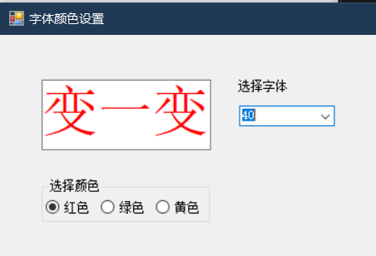

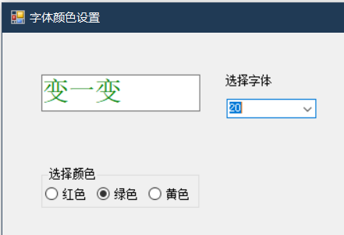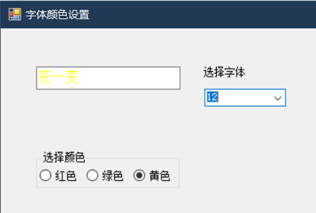

2.

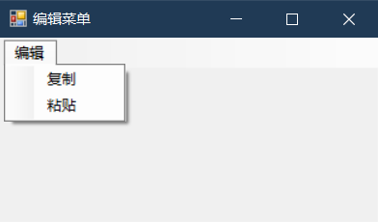

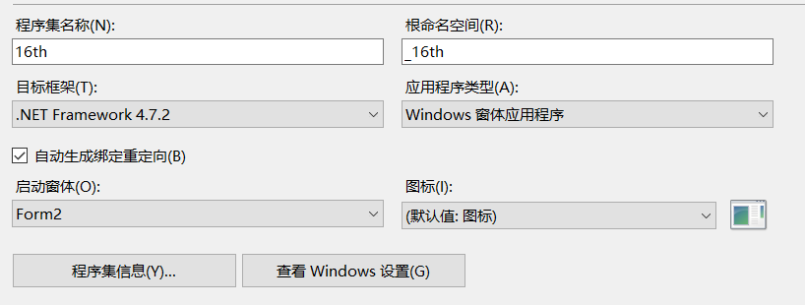

3.

Public Class Form2

Private Sub 复制ToolStripMenuItem1_Click(sender As Object, e As EventArgs) Handles 复制ToolStripMenuItem1.Click

Label1.Text = Label1.Text + Str(TextBox1.SelectionStart)

End Sub

Private Sub 粘贴ToolStripMenuItem1_Click(sender As Object, e As EventArgs) Handles 粘贴ToolStripMenuItem1.Click

TextBox2.Text = TextBox1.SelectedText

Label2.Text = Label2.Text & TextBox2.Text.Length

End Sub

End Class

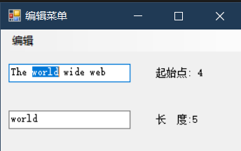

4.

Private Sub 字体颜色变化ToolStripMenuItem_Click(sender As Object, e As EventArgs) Handles 字体颜色变化ToolStripMenuItem.Click

test1.Show()

Me.Finalize()

End Sub

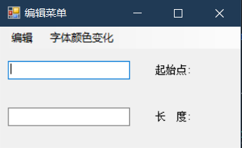

5.

Public Class Form3

Dim x As Single, y As Single, w As Integer

Private Sub Timer1_Tick(sender As Object, e As EventArgs) Handles Timer1.Tick

x = PictureBox1.Location.X

If (y >= (Me.Height - 1.8 * PictureBox1.Height) **Or** y < 0) Then

w = -w

End If

y = y **+** w

PictureBox1.Location = New Point(x, y)

End Sub

Private Sub Form3_Load(sender As Object, e As EventArgs) Handles Me.Load

Timer1.Enabled = **True**

w = 10

End Sub

End Class

红色为改错部分，绿色为修正（弹起更接近边缘）

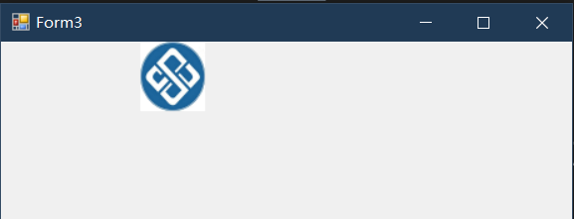

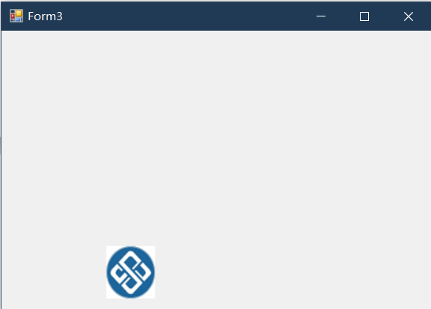

6.

Public Class Form4

Public login_fail_num As Integer '窗体级变量

Private Sub Button1_Click(sender As Object, e As EventArgs) Handles Button1.Click

If (TextBox1.Text = "user" And TextBox2.Text = "1111") Then

MsgBox("密码正确，成功登陆",, "提示")

login_fail_num = 0

Else

login_fail_num += 1

MsgBox("用户名或密码错误，请重新输入",, "提示")

TextBox1.SelectionStart = 0

TextBox1.SelectionLength = TextBox1.Text.Length

TextBox1.Focus()

TextBox2.Text = ""

End If

If (login_fail_num > 3) Then

MsgBox("多次错误，即将关闭",, "警告")

Me.Finalize()

End If

End Sub

Private Sub TextBox1_MouseEnter(sender As Object, e As EventArgs) Handles TextBox1.MouseEnter

TextBox1.SelectionStart = 0

TextBox1.SelectionLength = TextBox1.Text.Length

TextBox1.Focus()

End Sub

Private Sub Form4_Load(sender As Object, e As EventArgs) Handles Me.Load

TextBox1.Text = "请输入用户名"

TextBox2.Text = "请输入密码"

login_fail_num = 0

End Sub

Private Sub TextBox2_MouseEnter(sender As Object, e As EventArgs) Handles TextBox2.MouseEnter

TextBox2.SelectionStart = 0

TextBox2.SelectionLength = TextBox1.Text.Length

TextBox2.Focus()

End Sub

End Class

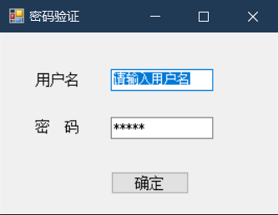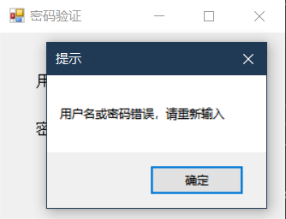

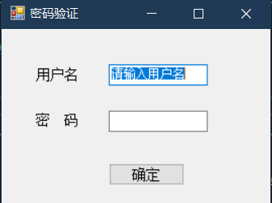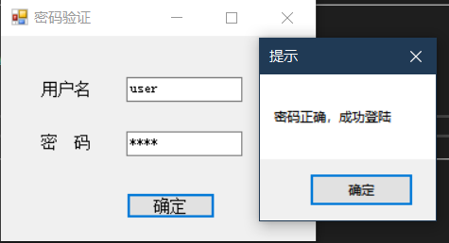

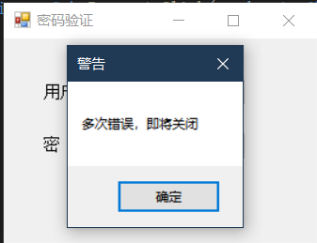

**实验17**

1.

‘welcome---------------------------------------------欢迎

Public Class welcome

Private Sub PictureBox1_Click(sender As Object, e As EventArgs) Handles PictureBox1.Click

Me.Finalize()

sur.Show()

End Sub

End Class

‘sur-----------------------------------------------------调查

Public Class sur

Private Sub Button1_Click(sender As Object, e As EventArgs) Handles Button1.Click

Dim str As String, i As Integer

str = "你喜欢的是"

For i = 1 To 4 Step 1

Dim tempcheck As CheckBox

tempcheck = CType(GroupBox1.Controls("CheckBox" & i), CheckBox)

If tempcheck.Checked Then

str = str & tempcheck.Text & " "

a(i) = a(i) + 1

End If

Next i

MsgBox(str,, "调查")

n += 1

End Sub

Private Sub Button2_Click(sender As Object, e As EventArgs) Handles Button2.Click

sta.Show()

End Sub

Private Sub Button3_Click(sender As Object, e As EventArgs) Handles Button3.Click

Me.Finalize()

End Sub

End Class

‘sta------------------------------------------------------------------------统计

Public Class sta

Private Sub sta_Load(sender As Object, e As EventArgs) Handles Me.Load

Dim i As Integer, str2 As String

str2 = ""

For i = 1 To 4 Step 1

Dim tcheck As CheckBox

tcheck = CType(sur.GroupBox1.Controls("CheckBox" & i), CheckBox)

str2 = str2 & "喜欢" & tcheck.Text & "的有" & a(i) & "人" & vbCrLf

Next i

Label1.Text = "有" & n & "人参加调查" & vbCrLf & str2

End Sub

End Class

‘module------------------------------------------------------------------模块

Module Module1

Public a(4) As Long, n As Long

End Module

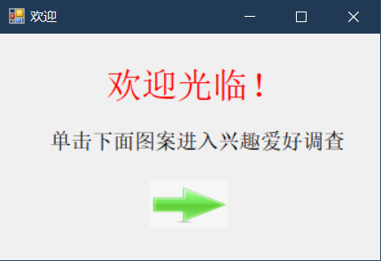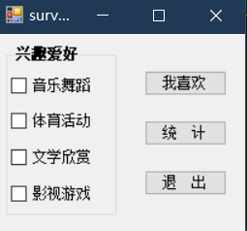

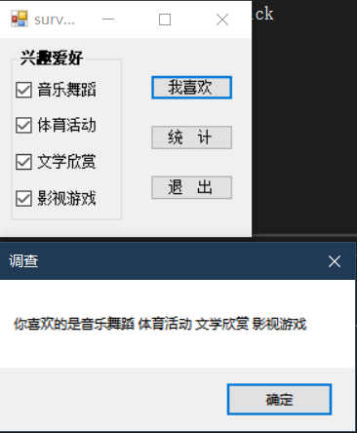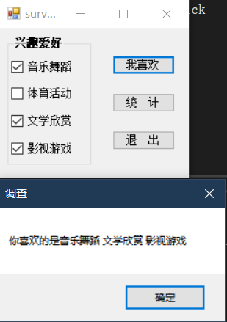

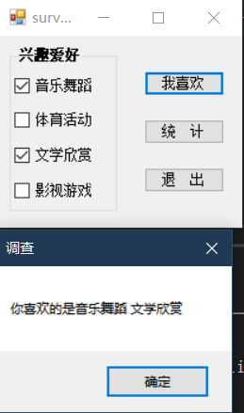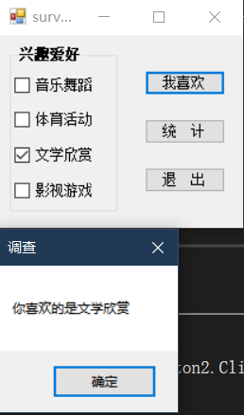

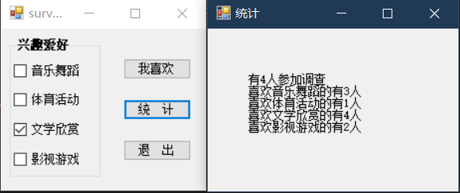

**实验18**

**1.略**

**2.**

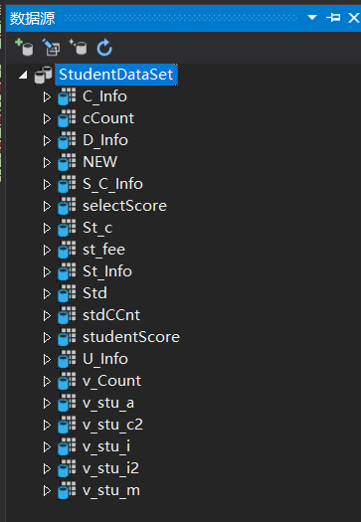

**3.**

Public Class Form1

Private Sub Form1_Load(sender As Object, e As EventArgs) Handles MyBase.Load

'TODO: 这行代码将数据加载到表“StudentDataSet.St_Info”中。您可以根据需要移动或删除它。

Me.St_InfoTableAdapter.Fill(Me.StudentDataSet.St_Info)

End Sub

End Class

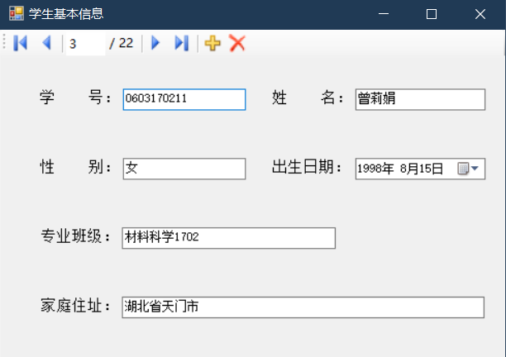

4.

Public Class Form2

Private Sub Form2_Load(sender As Object, e As EventArgs) Handles MyBase.Load

'TODO: 这行代码将数据加载到表“StudentDataSet.C_Info”中。您可以根据需要移动或删除它。

Me.C_InfoTableAdapter.Fill(Me.StudentDataSet.C_Info)

End Sub

Private Sub Button1_Click(sender As Object, e As EventArgs) Handles Button1.Click

Me.C_InfoBindingSource.MoveFirst()

End Sub

Private Sub Button3_Click(sender As Object, e As EventArgs) Handles Button3.Click

Me.C_InfoBindingSource.MoveNext()

End Sub

Private Sub Button2_Click(sender As Object, e As EventArgs) Handles Button2.Click

Me.C_InfoBindingSource.MovePrevious()

End Sub

Private Sub Button4_Click(sender As Object, e As EventArgs) Handles Button4.Click

Me.C_InfoBindingSource.MoveLast()

End Sub

End Class

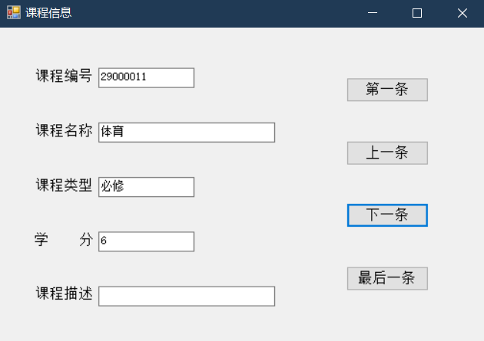

5.

Imports System.ComponentModel

Public Class Form3

Private Sub Form3_Load(sender As Object, e As EventArgs) Handles MyBase.Load

'TODO: 这行代码将数据加载到表“StudentDataSet.C_Info”中。您可以根据需要移动或删除它。

Me.C_InfoTableAdapter.Fill(Me.StudentDataSet.C_Info)

End Sub

Private Sub Button2_Click(sender As Object, e As EventArgs) Handles Button2.Click

'Me.Finalize()

Form2.Show()

End Sub

Private Sub Button1_Click(sender As Object, e As EventArgs) Handles Button1.Click

Me.BindingSource1.AddNew()

Me.BindingSource1.EndEdit()

Me.C_InfoTableAdapter.Update(StudentDataSet.C_Info)

'Me.C_InfoTableAdapter.Fill(Me.StudentDataSet.C_Info)

End Sub

Private Sub BindingSource1_AddingNew(sender As Object, e As AddingNewEventArgs) Handles BindingSource1.AddingNew

'e.NewObject = k_c.CreateNewkc(C_NoTextBox.Text, C_NameTextBox.Text, C_TypeTextBox.Text, Val(C_CreditTextBox.Text), C_DesTextBox.Text)

Dim bs As BindingSource = sender

Dim view As DataView = bs.List

Dim newrow As DataRowView = view.AddNew()

newrow("C_No") = C_NoTextBox.Text

newrow("C_Name") = C_NameTextBox.Text

newrow("C_Type") = C_TypeTextBox.Text

newrow("C_Credit") = C_CreditTextBox.Text

newrow("C_Des") = C_DesTextBox.Text

e.NewObject = newrow

Debug.Print(newrow("C_No"))

End Sub

End Class

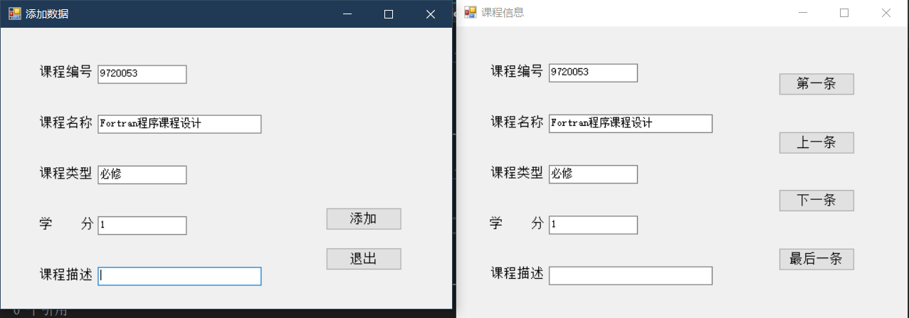

6.

Public Class Form4

Private Sub Button1_Click(sender As Object, e As EventArgs) Handles Button1.Click

Me.CInfoBindingSource.EndEdit()

Me.C_InfoTableAdapter.Update(StudentDataSet.C_Info)

End Sub

Private Sub Button2_Click(sender As Object, e As EventArgs) Handles Button2.Click

Me.CInfoBindingSource.EndEdit()

Me.C_InfoTableAdapter.Delete(Trim(C_NoTextBox.Text), Trim(C_NameTextBox.Text), Trim(C_TypeTextBox.Text), Trim(C_CreditTextBox.Text), Trim(C_DesTextBox.Text))

End Sub

Private Sub Button3_Click(sender As Object, e As EventArgs) Handles Button3.Click

Me.Finalize()

Me.Close()

End Sub

Private Sub Form4_Load(sender As Object, e As EventArgs) Handles MyBase.Load

'TODO: 这行代码将数据加载到表“StudentDataSet.C_Info”中。您可以根据需要移动或删除它。

Me.C_InfoTableAdapter.Fill(Me.StudentDataSet.C_Info)

End Sub

End Class

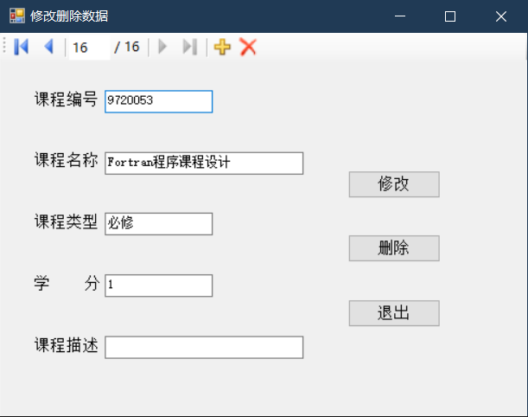

7.

Public Class Form5

Private Sub Form5_Load(sender As Object, e As EventArgs) Handles MyBase.Load

'TODO: 这行代码将数据加载到表“StudentDataSet.C_Info”中。您可以根据需要移动或删除它。

Me.C_InfoTableAdapter.Fill(Me.StudentDataSet.C_Info)

End Sub

Private Sub ComboBox1_SelectedIndexChanged(sender As Object, e As EventArgs) Handles ComboBox1.SelectedIndexChanged

If (ComboBox1.SelectedIndex >= 0) Then

TextBox1.Text = ComboBox1.SelectedValue

End If

End Sub

End Class

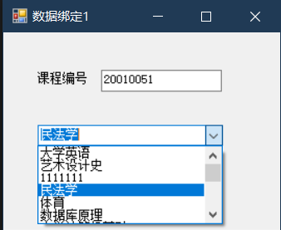

1111111为测试数据没有删除

8.

Public Class Form6

Private Sub Form6_Load(sender As Object, e As EventArgs) Handles MyBase.Load

'TODO: 这行代码将数据加载到表“StudentDataSet.St_Info”中。您可以根据需要移动或删除它。

Me.St_InfoTableAdapter.Fill(Me.StudentDataSet.St_Info)

'TODO: 这行代码将数据加载到表“StudentDataSet.vClname”中。您可以根据需要移动或删除它。

Me.VClnameTableAdapter.Fill(Me.StudentDataSet.vClname)

End Sub

Private Sub ComboBox1_SelectedIndexChanged(sender As Object, e As EventArgs) Handles ComboBox1.SelectedIndexChanged

StInfoBindingSource.Filter = "Cl_Name ='" & Trim(ComboBox1.Text) & "'"

End Sub

End Class

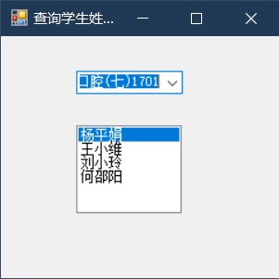

9.

Public Class Form7

Private Sub Form7_Load(sender As Object, e As EventArgs) Handles MyBase.Load

'TODO: 这行代码将数据加载到表“StudentDataSet.C_Info”中。您可以根据需要移动或删除它。

Me.C_InfoTableAdapter.Fill(Me.StudentDataSet.C_Info)

'TODO: 这行代码将数据加载到表“StudentDataSet.S_C_Info”中。您可以根据需要移动或删除它。

Me.S_C_InfoTableAdapter.Fill(Me.StudentDataSet.S_C_Info)

End Sub

Private Sub ComboBox1_SelectedIndexChanged(sender As Object, e As EventArgs) Handles ComboBox1.SelectedIndexChanged

SCInfoBindingSource.Filter = "C_No= '" & Trim(ComboBox1.SelectedValue) & "'"

End Sub

End Class

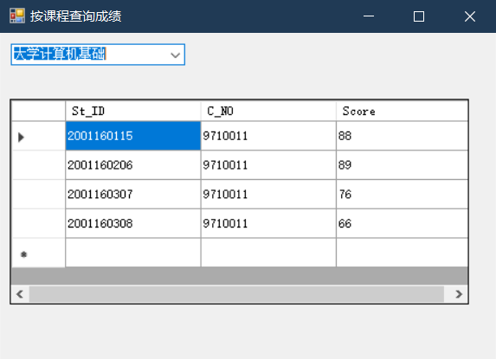

**实验19**

1.

1.4

D_ID

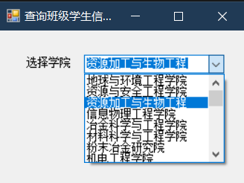

1.5

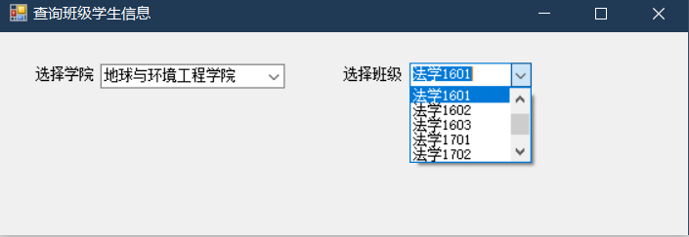

1.8

Filter

Selectedvalue

Public Class Form1

Private Sub Form1_Load(sender As Object, e As EventArgs) Handles MyBase.Load

'TODO: 这行代码将数据加载到表“StudentDataSet.vDCname”中。您可以根据需要移动或删除它。

Me.VDCnameTableAdapter.Fill(Me.StudentDataSet.vDCname)

'TODO: 这行代码将数据加载到表“StudentDataSet.vClname”中。您可以根据需要移动或删除它。

Me.VClnameTableAdapter.Fill(Me.StudentDataSet.vClname)

'TODO: 这行代码将数据加载到表“StudentDataSet.D_Info”中。您可以根据需要移动或删除它。

Me.D_InfoTableAdapter.Fill(Me.StudentDataSet.D_Info)

End Sub

Private Sub ComboBox1_SelectedIndexChanged(sender As Object, e As EventArgs) Handles ComboBox1.SelectedIndexChanged

VDCnameBindingSource.Filter = "D_ID= '" & Trim(ComboBox1.SelectedValue) & "'"

End Sub

End Class

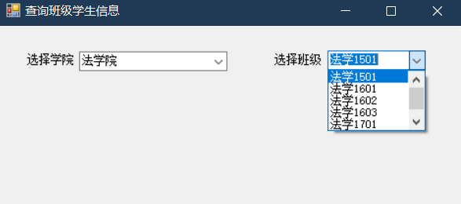

1.9

Public Class Form1

Private Sub Form1_Load(sender As Object, e As EventArgs) Handles MyBase.Load

'TODO: 这行代码将数据加载到表“StudentDataSet.St_Info”中。您可以根据需要移动或删除它。

Me.St_InfoTableAdapter.Fill(Me.StudentDataSet.St_Info)

'TODO: 这行代码将数据加载到表“StudentDataSet.vDCname”中。您可以根据需要移动或删除它。

Me.VDCnameTableAdapter.Fill(Me.StudentDataSet.vDCname)

'TODO: 这行代码将数据加载到表“StudentDataSet.vClname”中。您可以根据需要移动或删除它。

Me.VClnameTableAdapter.Fill(Me.StudentDataSet.vClname)

'TODO: 这行代码将数据加载到表“StudentDataSet.D_Info”中。您可以根据需要移动或删除它。

Me.D_InfoTableAdapter.Fill(Me.StudentDataSet.D_Info)

End Sub

Private Sub ComboBox1_SelectedIndexChanged(sender As Object, e As EventArgs) Handles ComboBox1.SelectedIndexChanged

VDCnameBindingSource.Filter = "D_ID= '" & Trim(ComboBox1.SelectedValue) & "'"

StInfoBindingSource.Filter = "Cl_name= '" & Trim(ComboBox2.Text) & "'"

End Sub

Private Sub ComboBox2_SelectedIndexChanged(sender As Object, e As EventArgs) Handles ComboBox2.SelectedIndexChanged

StInfoBindingSource.Filter = "Cl_name= '" & Trim(ComboBox2.Text) & "'"

End Sub

End Class

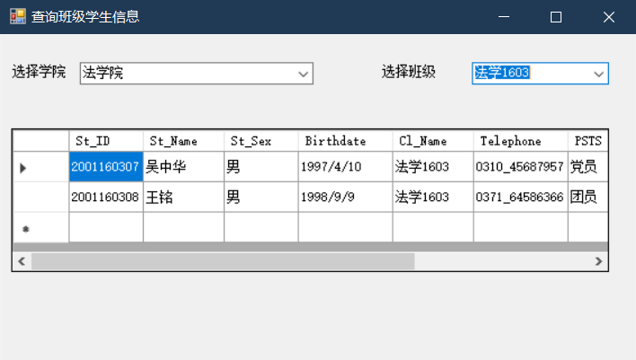

2.

Public Class Form2

Private Sub Form2_Load(sender As Object, e As EventArgs) Handles MyBase.Load

'TODO: 这行代码将数据加载到表“StudentDataSet.vNameScore”中。您可以根据需要移动或删除它。

Me.VNameScoreTableAdapter.Fill(Me.StudentDataSet.vNameScore)

'TODO: 这行代码将数据加载到表“StudentDataSet.vDCname”中。您可以根据需要移动或删除它。

Me.VDCnameTableAdapter.Fill(Me.StudentDataSet.vDCname)

'TODO: 这行代码将数据加载到表“StudentDataSet.vClname”中。您可以根据需要移动或删除它。

Me.VClnameTableAdapter.Fill(Me.StudentDataSet.vClname)

'TODO: 这行代码将数据加载到表“StudentDataSet.C_Info”中。您可以根据需要移动或删除它。

Me.C_InfoTableAdapter.Fill(Me.StudentDataSet.C_Info)

End Sub

Private Sub ComboBox1_SelectedIndexChanged(sender As Object, e As EventArgs) Handles ComboBox1.SelectedIndexChanged

VNameScoreBindingSource.Filter = "C_No= '" & Trim(ComboBox1.SelectedValue) & "'"

End Sub

Private Sub ComboBox2_SelectedIndexChanged(sender As Object, e As EventArgs) Handles ComboBox2.SelectedIndexChanged

VNameScoreBindingSource.Filter = "Cl_Name= '" & Trim(ComboBox2.Text) & "'"

End Sub

End Class

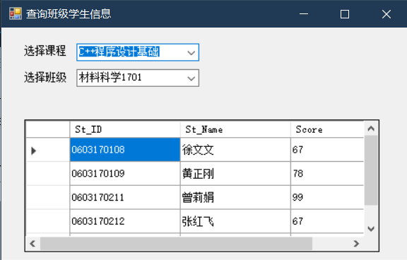

曾莉娟是我之前添加的数据，查询合理

create view vNameScore

as

select st.St_ID,st.St_Name,sc.C_NO,c.C_Name,sc.Score,c.C_Credit,st.Cl_Name

from St_Info st inner join S_C_Info sc on st.St_ID=sc.St_ID inner join C_Info c on sc.C_NO = c.C_No

创建视图代码

3.

Public Class Form3

Private Sub Form3_Load(sender As Object, e As EventArgs) Handles MyBase.Load

'TODO: 这行代码将数据加载到表“StudentDataSet.vNameScore”中。您可以根据需要移动或删除它。

Me.VNameScoreTableAdapter.Fill(Me.StudentDataSet.vNameScore)

Dim s As Integer, i As Integer

With Form1.DataGridView1

Label1.Text = Label1.Text & .Item(1, .CurrentCell.RowIndex).Value.ToString

VNameScoreBindingSource.Filter =

"st_id= '" & Trim(.Item(0, .CurrentCell.RowIndex).Value.ToString) & "'"

End With

For i = 0 To VNameScoreBindingSource.Count - 1

If (VNameScoreBindingSource.Current(4) > 60) Then

s = s + VNameScoreBindingSource.Current(5)

End If

VNameScoreBindingSource.MoveNext()

Next

Label2.Text = Label2.Text & s

End Sub

End Class

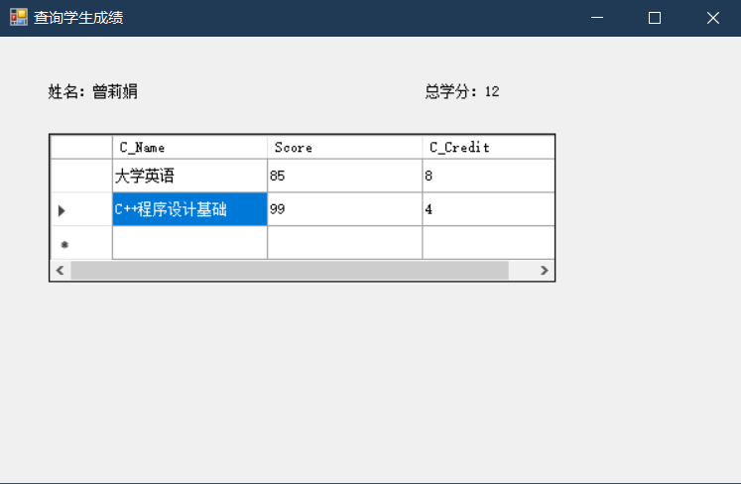

4.

Public Class Form5

Private Sub mnQSt_Click(sender As Object, e As EventArgs) Handles mnQSt.Click

Form1.MdiParent = Me

Form1.Show()

End Sub

Private Sub mnQScore_Click(sender As Object, e As EventArgs) Handles mnQScore.Click

Form2.MdiParent = Me

Form2.Show()

End Sub

End Class

